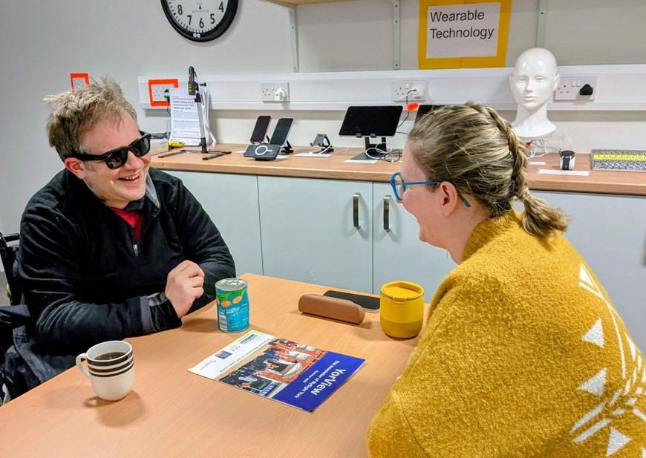
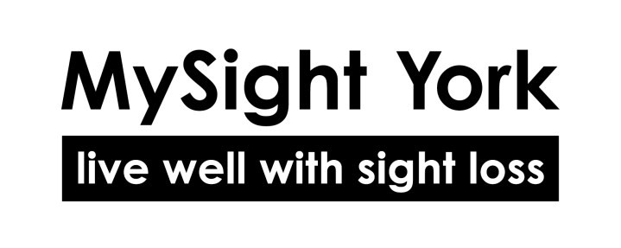
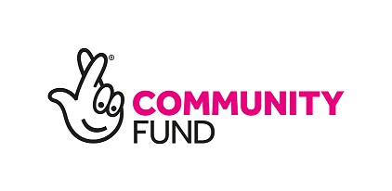


YorView
Reg. Charity No: 1159188
The newsletter of MySight York
Winter 2025

Demonstrating the Meta Ray Ban glasses. See page 12 for
more information on this and other technology.




From the Editor…
YorView
is the Newsletter of MySight York
Ground Floor 84-86 Walmgate York, YO1 9TL
Tel. 01904 636269

Email: hello@mysightyork.org www.mysightyork.org
Chief Executive: Scott Jobson

www.facebook.com/ mysightyork

@mysightyork

www.linkedin.com/ company/mysight-york

YorView is published quarterly.
It is available in large print, braille, audio (USB or CD) on Alexa and at www.mysightyork.org
Editor: Barbara Fairs
Hello and welcome to the final newsletter of 2025. It’s hard to believe another year has gone by and Christmas is on the horizon.
Speaking of Christmas, we have information on our Christmas party on page 20 and other events we are taking part in on page 19.
Bex brings us exciting news about the new technology we have for you to try in our E&I centre and Digital Cafes we are running to help you increase your confidence around assistive technology. See pages 12-14 for more information.
Deb gives us an overview of the range of large print calendars and diaries available, as well as news of the new RNB Accord usb player. On pages 10-11.
We also say hello to Tanya, our new Volunteer Coordinator on page 8 and Vicky updates us on the exciting work the Community Connect project has been doing in the last few months, page 16.
We would love to see you at one of Christmas stalls or events but, if we don’t, may I take this opportunity to wish you a very Merry Christmas and a peaceful New Year.
Barbara

- From the Chief Executive Scott Jobson gives the view from the Chief Exec’s office
In this issue

Visionary Award and Sight Loss Friendly York
News of our recent Accelerating Impact Award from Visionary

News in Brief
  - Tea and Coffee Club
  - Living well with Sight Loss courses
  - Sighted Guiding for friends and
family

News in Brief contd.
  - Accessible guides and publications
  - Christmas closure dates

Volunteering Update
Hello and welcome to Tanya, our new Volunteer Coordinator

York Disability Week
Sight loss and Hearing loss awareness training for businesses

New in the E&I
Deb gives us the latest on diaries, calendars and the new Accord player from RNIB

12 Digital and Tech Support
Bex gives us an insight into the accessible technology available to try in the E&I

14 Digital Cafes
A rundown on the upcoming friendly and informal group sessions

15 Regular Activities Louise updates us on the current list of activities

16 Community Connect Update Vicky gives us the latest news including a “try the train” trip
and the recent Sight Loss Friendly status award recipients

18 Out and About at Christmas Anyone for a Christmas panto? Oh yes you do!

19 MySight York Festive Celebrations
News of the Christmas stall and events MySight York is taking part in

20 Invitation to the Christmas Party
Come and join us for a Christmas celebration

From the Chief Executive

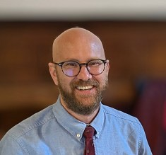
As we come to the end of another year, I want to thank everyone who joined us for our Annual General Meeting in October. It was
wonderful to see so many
members, volunteers, and partners gathered together to celebrate everything we’ve achieved over the past 12 months. Your support and enthusiasm are what keep this organisation strong.
I’d also like to take a moment to thank John Sole, who has now stepped down as Chair of our Board of Trustees. John has been an exceptional leader and a steady hand through a time of great
change. His warmth, wisdom, and humour have guided us brilliantly, and his contribution to MySight York will be felt for years to come.
This year has been one of growth and progress. Our services remain busy, valued, and focused on what matters most: helping people with sight loss live confidently and independently. From our Eye Clinic Liaison Service and Talking Space counselling, to our Equipment and Information Centre, every area of our work continues to make a genuine difference.
We’ve also seen exciting developments in our digital inclusion work, with new equipment available for demonstration and the continued success of our Digital Champions programme. It’s been wonderful to see more people building confidence with technology, whether it’s mastering a smartphone, exploring magnification tools, or simply feeling more connected with family and friends.
This autumn also brought national recognition for our Community Connect project, which won the Accelerating Impact Award at the Visionary UK Awards 2025. Read more on this huge achievement on page 5.
As we look ahead to 2026, our priorities remain clear: to expand access to support, to strengthen peer connections, and to continue building a York where people with sight loss feel included, heard, and valued.
Thank you for being part of this journey. Every success we’ve achieved this year has been made possible by the involvement of our members and volunteers. Together, we’re shaping a stronger, more inclusive future for people with sight loss in York.
Wishing you all a peaceful and happy festive season.
Scott

We are delighted to share that MySight York has won the Accelerating Impact Award at the Visionary UK Awards 2025, sponsored by Fight for Sight.
Visionary Award & Sight Loss Friendly York
Voted for by sight loss organisations across the country, this national award celebrates projects that create meaningful and lasting change. It recognises the impact of Community Connect, our peer-led initiative that is helping to make York a truly Sight Loss Friendly City, one organisation at a time.
Through Community Connect, people with sight loss work directly with local organisations to make practical improvements to accessibility and inclusion. Over the past three years, hundreds of members have helped shape change across York, from inclusive sports and sensory storytelling to digital skills sessions and accessible heritage events.
More than 40 community-focused organisations and businesses are working with us to achieve Sight Loss Friendly Status This status is more than a certificate; it is a clear message that says, you are welcome here.
Recently, we were proud to present Sight Loss Friendly awards to two outstanding York organisations.
The National Centre for Early Music (NCEM) achieved their certificate during their first Cuppa and a Chorus singing session. Dr Christopher Roberts, Operations Manager at NCEM, said:
“One of our core values is being welcoming to all. We are always looking to engage with new audiences, so it was fantastic to celebrate our Sight Loss Friendly Status with MySight York.”
Earlier this autumn, Holy Trinity
Church, Goodramgate, part of The Churches Conservation Trust, also achieved the status. Their thoughtful accessibility improvements, from low-vision markings in dark spaces to creative Sensory Tours, have set a new standard for inclusion.
Both organisations show what is possible when people listen, learn and act. By working alongside our team, they have transformed not only their spaces but their approach to inclusivity.
This is the heart of Community Connect: collaboration that leads to change. When people with lived experience help shape decisions, accessibility becomes integral rather than an afterthought.
Together, we are building a more inclusive York
This work has been proudly supported by the National Lottery Community Fund.

Tea and Coffee Club at York University
The Tea and Coffee Club is a weekly, volunteer run project at York University where volunteers spend time with local elderly residents to help overcome loneliness and promote inter-generational bonds.
The sessions run every Monday from 11am to 12.30pm at David Kato College in the University of York.
Parking is available and help with transport can be provided.
Contact teaandcoffee@yorksu.org
for more information.

RNIB Living Well with Sight Loss Course, delivered by MySight York 6th and 20th March 2026 10:30 - 2:00pm
News in brief

Have you or a family member been diagnosed with sight loss, are you experiencing recent changes with your sight or are you new to the area? Come along and share experiences with others in similar situations and get practical advice and information.

These free informal courses aim to help you increase independence, boost confidence and connect with others.

Previous attendees said:
“The experience is both emotional and educational.”
“People listening to your shared
story is really useful.”

Booking essential, plus ones are welcome. Call Vicky on 01904
636269 or email Vicky.colombi@mysightyork.org

An introduction to Sighted Guiding for Friends and Family
13th Feb 2026 12noon- 1pm
Following on from the success of our taster session during York’s 50+ Festival, we are running
another free, introductory session of sighted guiding aimed specifically at family and friends.
This will take place at our premises on Walmgate, and aims to provide practical tips to confidently guide a friend or loved one with sight loss. enhancing their independence in everyday settings.
This session is perfect for those needing occasional support in changing light or diverse environments and will enhance the understanding of family and friends in how they can best support their loved one.
Booking is essential. Call 01904 6362969 or email Vicky.colombi@mysightyork.org

Accessible Guides and
Publications
Boots
2025 will be the 20th consecutive year that RNIB have worked with Boots to provided accessible versions of their Christmas Gift Guide.

The Christmas Gift Guide is available in audio, braille and large print.
Customers can order their free accessible copy now.
Call 0345 070 8090 or email boots.customercareteam@boots.co
.uk

The content will also be available online, including an accessible PDF of the Gift Guide at https:// www.boots.com/christmas-gift-guide/accessible-gift-guide.

M&S
Christmas Food Magazine available in audio and braille. Braille copies can be ordered by emailing brochurerequests@marks
-and-spencer.com.

Lakeland
Christmas Magazine available in audio. Requests to Net.shop@lakeland.co.uk or call 01539 488100
Other organisations offer free content year round:
Alzheimer’s Society Dementia together bi-monthly magazine
Available in audio. Requests to magazine@alzheimers.org.uk or call 0330 333 0804.
British Heart Foundation Keep your heart healthy publication.
Braille copies of the booklet can be ordered via the following link: https://www.bhf.org.uk/ informationsupport/publications/ keep-your-heart-healthy-braille-version.

Deafblind
Open Hand magazine available in audio and braille. Requests here: https://deafblind.org.uk/get-support/ open-hand-magazine/


7
MySight York will be closed for Christmas on the following dates: Closed from Friday 19th December at 3pm
Re-open Monday 5th January at 9am

We wish everyone a very Merry Christmas and a Happy New Year!

Welcome to Tanya McClelland, Volunteer Coordinator

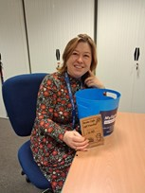
Hello everyone!
Volunteering Update
I probably haven’t had the pleasure of meeting of you yet – I’m Tanya, the new volunteer Coordinator!
It’s been two months since I have started employment here at
MySight York and I have to say that I’m really enjoying it. Everyone has been so welcoming and friendly. It’s hard to believe that I have been here only a short while as I do feel really ‘rooted’ in already and that I’m taking that as a sure sign of
good things to come.
The small but mighty staff team continue to impress me with their utter dedication and generosity in providing the vital services they manage for members.
They take the time to share useful tips to help me understand the complicated charity log system and provide useful background so that I have a better picture of a members needs and how our work can
support individuals to live well with sight loss. You can tell that they really care about this community.
I’m also really relishing working within our office in Walmgate. It’s a very dynamic workspace and I’ve enjoyed the opportunity to chat to members and volunteers on their
way to activities and appointments. (I must apologise for all the milky teas and coffees I’ve produced
lately – there is definitely room for improvement there!)
I’m finding being a volunteer coordinator a very dynamic, expansive and exciting role. I’ve been very busy on the ground recruiting new volunteers, conducting interviews, catching up on supervisions, doing a bit of troubleshooting here and there and helping existing volunteers branch out into other roles.
As well as this I have been out and about meeting members in their homes as part of the befriending service. I count this aspect of the role a great privilege. Member Alan has just welcomed a new home visitor, he says “Having a home visitor means that my wife can have some time to herself and go out and about. This is very important to me. I now have someone to talk to. It’s making me feel a bit better”
All in all, my last two months has been an enormous learning curve but I have made a commitment to
making strong connections with our clients and volunteers. I hope to ensure this is at the heart of everything of I do here at MySight York.



As part of Befriending Week 2025, Befriending Networks have released a free e-learning course called 'Creating Social Connections' - this is a short course exploring the social importance of meaningful connection for befrienders.
This is a practical course for new, aspiring, or returning befrienders exploring the social connection, barriers to engagement, and skills like empathy, active listening, and rapport-building to reduce loneliness. You can find this along with other useful resources on their website.
Find it at https:// befriending.co.uk/e-learning/
If you would like to know more
about becoming a befriender then please do get in touch with me for a chat
In the Spring edition of the newsletter we will be hearing from Megan, a University of York
Student, who has recently been recruited as Befriending Client monitor. Stay tuned.
How to get in touch with Tanya: Tanya.mcclelland@mysightyork. org or call 01904 731122
My working hours are Tues-Thurs 9.00am to 3.40pm

York Disability Week
MySight York is thrilled to be collaborating with Living 4 Moments to offer Sight and Hearing Loss Awareness for Businesses through York Business Improvement District as part of York Disability Week.
This comprehensive taster session is designed to improve business inclusivity and will help them to learn about the “Purple Pound” and the significant spending power of disabled people.
Attendees on the course will gain practical insights into supporting disabled customers through accessible social media training, sighted guiding, lipreading and disability awareness.
The course is due to take place on

Tuesday 2nd December 2.45pm -
4.15pm at Room Foss 036, York St John University, Lord Mayor's Walk, YO31 7EX .
It is free to attend and can be booked via
https://www.eventbrite.co.uk/e/ sight-hearing-loss-awareness-for-businesses-tickets-1852447573559?
aff=oddtdtcreator or call the York
BID office on 01904 809970.
More information on other events running in York Disability week can be found at https:// sites.google.com/view/iddpyork/ whole-programme

By Deborah Wheller

As we come to the end of the year we are pleased to announce that 2026 diaries and calendars are now in stock.
New in the E & I
The products have good quality white paper which prevents ink bleeding through with large clear black text.
From the RNIB with black and blue covers this year.
A3 Portrait wall calendar £8.00 Two columns with black numbers on white background, weekends white on black, one month per
page.
A4 Diary £11.00 One week over two pages with space for notes.
Desk diary £11.00 One week over two pages with space for notes.
A6 pocket diary £8.00 with space for personal details, special occasions, forward planning and
30, address entries.
The VIP range have yellow covers once again.

A4 Wall Portrait Wall calendar
£8.00 Two columns with white numbers on black , one month per page.
A4 desk diary £10.50 white numbers on black background and
space for notes One week over two pages.
A5 midi diary £8.50 White numbers on black background with space for notes.
A6 Pocket diary £6.50 White numbers on black background
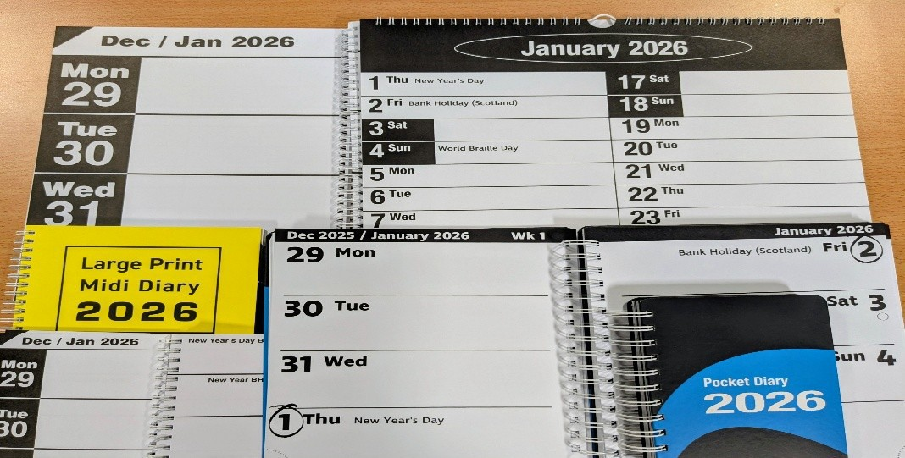

The RNIB also have a Big Print Address Book £11, which is made with a bright orange cover. It allows you to add two addresses per
page.

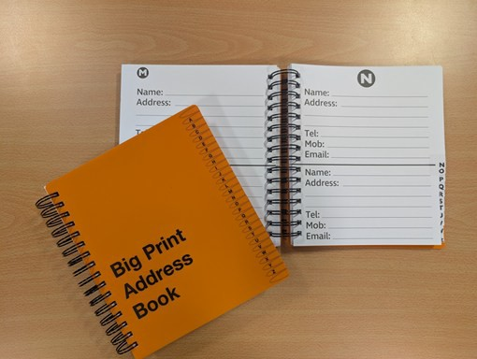

Liquid level indicator (LLI) RNIB
£16.00 ex VAT
The RNIB have made changes to their popular Liquid Level indicator, replacing the type of battery
needed and the way it is changed to improve safety and make battery changing easier. With a flip up cover it now uses a single AAA battery.
By hanging the LLI unit on the side of your mug with the three metal probes on the inside you can carefully pour your hot or cold liquid. You will know when to stop pouring when it emits a set of intermittent beeps and vibrations.
Making a cup of tea for example the longest probes alert you when to stop pouring hot water if you also want to add milk; the second alert tells you when the cup is nearly full and to stop pouring anything further into the cup. This still gives you a good cm below the rim of the cup which means that you can move it without spilling.
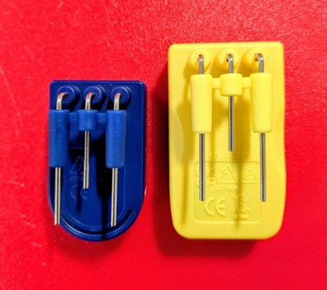
Old and new LLI in comparison

Accord USB Speaker RNIB
£52.99 ex VAT
The RNIBs new and improved Accord player is back in stock. The new device is a combination of a Bluetooth speaker and a USB speaker. The player has been designed to be more accessible, with high contrast and tactile buttons as well as easy to locate
ports.
The Accord is small, a similar size to a can of beans, and portable.
The device can play any audio from other devices, like your phone or tablet, by using the Bluetooth connection.
The device is rechargeable and lasts for five to six hours on a full charge. The device is charged using the supplied USB C cable. However, this does not come with a plug, you may already have a compatible plug.
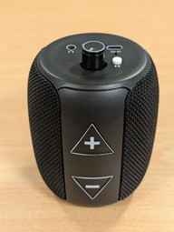
If you would like to explore this more please book an appointment on 01904 636 269.

By Bex Wood

Technology is a fast-changing landscape that can be difficult to navigate. Thanks to funding from the Two Ridings Community Foundation Q Futures Fund,
Digital and Tech Support
UKSPF Digital Inclusion Fund and the Feoffees of St Michael Spurriergate, we have been able to update some of the technology available in our Equipment and Information Centre We are now able to demonstrate and explore the following pieces of equipment with members:

Apple iPhone
Explore how the iPhone looks and feels and see its wide variety of accessibility features. Explore changes that can be made to your phone by first exploring them on our device. Or simply compare smartphones.
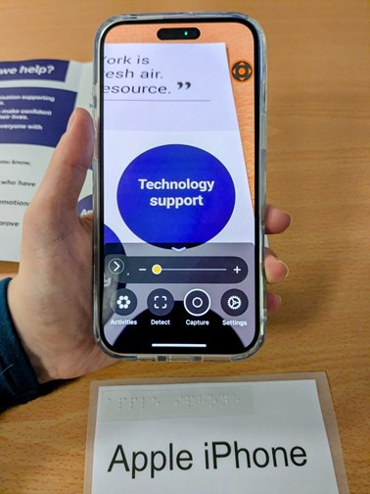

Apple iPad
Explore the iPad and its uses. Experience accessibility options and much more.
Meta Ray Ban Gen 1 glasses These are AI smart glasses that can help provide voice assistance, audio directions, and a hands-free option. They can describe what’s in front of you, read out messages, and help you stay connected and independent.
Shockz Open Run bone conducting headphones These headphones provide excellent sound quality whilst allowing you to be able to hear your surroundings.
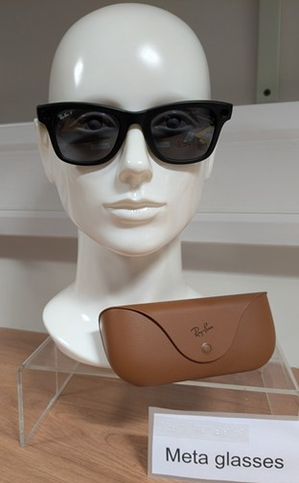
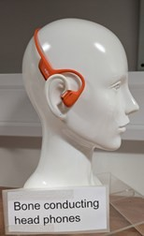
Samsung phone Explore the Samsung’s accessibility features and experience a device with
Synapptic’s software installed.

Samsung Tablet
Explore a Samsung tablet, discover what it can be used for and experience changes that can be made to make the device more accessible for you.

Google Pixel phone
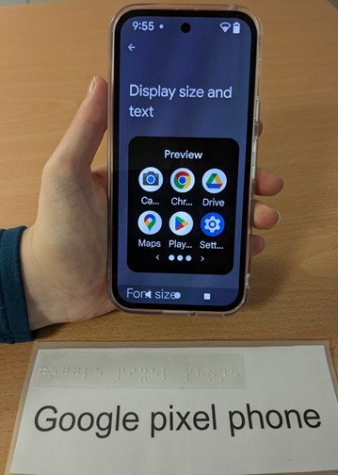
Explore a Google Pixel phone. Experience the accessibility functions, explore Google’s Gemini AI assistant and have a go with android’s features.

Synapptic tablet and phone
Synapptic is a piece of software
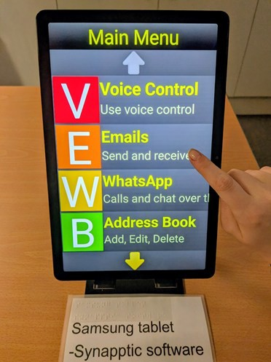
that will make mobile phones and tablets simple to use when you have sight loss. By making the interface simpler and speaking
aloud your actions it can make
devices more accessible.

Orcam Read 3 with AI function The Orcam Read 3 is a handheld device that can easily read any printed or digital document aloud.
With the Orcam’s smart AI
assistant you can ask for the text to
be summarized or ask questions
about the text.

Dolphin Guide Connect
Dolphin Guide Connect is software that helps people with visual impairments stay independent longer by making your computer accessible. It gives you the ability to navigate menus by listening to a voice, dictate text and customize the size of icons on the screen in a simple and accessible way.
We can also demonstrate assistive software for your computer that magnifies and screen reads, such as Fusion Zoomtext, Jaws and Dolphin Supernova.

To visit the Equipment and Information centre to explore any of this technology please call 01904 636 269 to make an appointment.
These bespoke appointments will go at your pace and cover what you would like help to achieve.

Thanks to our funders, some of our staff and volunteers have participated in training to become Digital Champions. Our aim is to help our members remain independent and confident in the digital world.
Digital Cafes

We are also running Digital Cafés each month, covering a variety of topics and providing information on a number of pieces of technology and apps available to help you in daily life. The following is the schedule of Digital Café’s until March:

- 4th December – Talking books on your mobile devices. Information on how to access your talking books on mobile devices in various ways.

- 8th January – Quick wins, basic android phone accessibility settings. Information on what settings can be changed on your android smartphones to make your device accessible for you.

- 5th February – Demonstration of Synapptics products, including the Synapptic phone and tablet, watch and USB
talking book player.

- 5th March – Optelec open day. Ian Thwaites from Optelec will be in the MySight York office to show some of Optelec’s assistive tech, including the new Orcam Read 3.
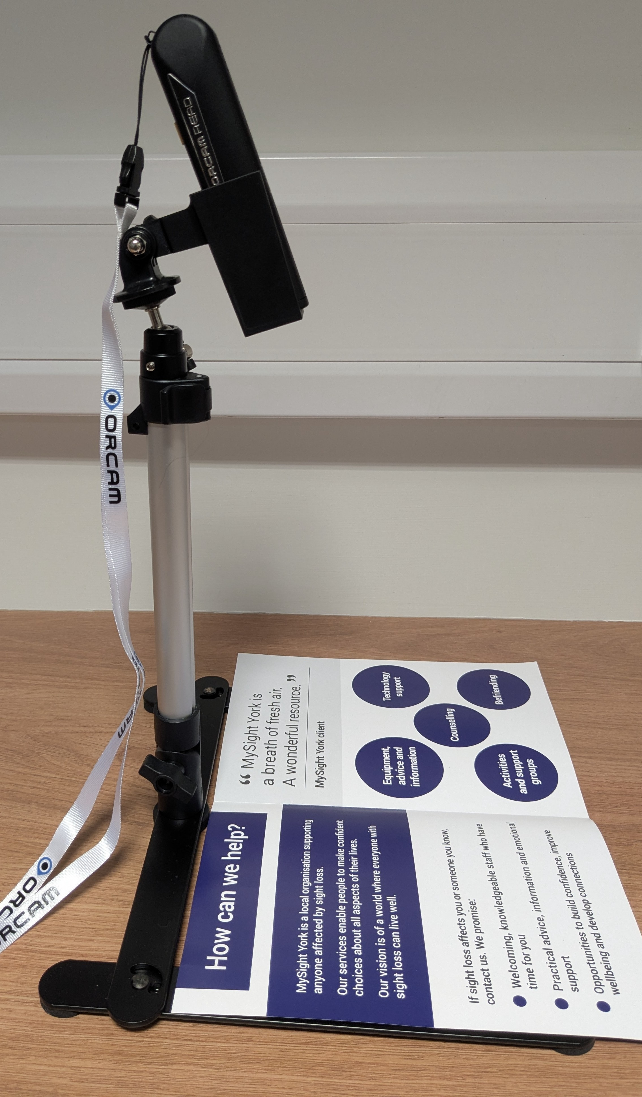

Orcam on stand

If you would like to attend these Digital Café’s please call on 01904 636269 to let us know .
If you have any suggestions for topics you would like to know about relating to digital inclusivity please contact Bex on 01904 636 69 or email at
bex.wood@mysightyork.org.

By Louise Calpin

Here is a reminder of the variety of groups and activities we offer.
Regular Activities
Whether you prefer meeting in person or by phone, we have something for everyone.
Support with MySight - If you’re new to sight loss, or simply need a supportive space, this group is for you. Meets every other month on the first Monday afternoon. In person only.
Esme’s Friends – Our support group for anyone who experiences visual hallucinations as a result of sight loss (also known as Charles Bonnet Syndrome). Monthly.
Hybrid Discussion Group or Telephone Discussion - Topics often include a thread connecting back to lived experience with sight loss. On the second Wednesday morning, of every other month, alternating with each other. Upon occasion, guest speakers are
invited.
Accessible Board Games - Accessible dominos, cards, scrabble and much more. Monday, weekly.
Knit and Natter - A friendly group
for those who love to knit (and natter). Twice a month.
Audio Book Group - The group discusses a different book each
session. Monthly.
Telephone Quiz - An enjoyable way to spend time with friends, old and new. Last Friday of the month.
Chair Exercise - run by Xercise Haxby at MySight York premises. Weekly.
Chair Tai Chi - run by UK Tai Chi via Zoom, at MySight York premises. Weekly. (This group is currently full, please contact Louise to be added to the waiting list).
VI Tennis - run by a York Disability Tennis Network qualified coach, held at the University of York, York Sports Centre. Supported by MySight York volunteers. Weekly.
VI Golf – Hosted at York Golf Club, players follow the same rules as all golfers, with a few minor
adjustments. Booking is essential.
Monthly.
Cuppa and a Chorus – Hosted at The National Centre for Early Music. Booking is essential.
Monthly.
If you are interested in joining any of our groups, or require further information, please contact Louise louise.calpin@mysightyork.org or call 01904 636269.

Funded by the National Lottery Reaching Communities Fund

Try the Train with Trans Pennine Express.
Community Connect Update
A consultation with TransPennine Express and MySight York Community Connect consultants
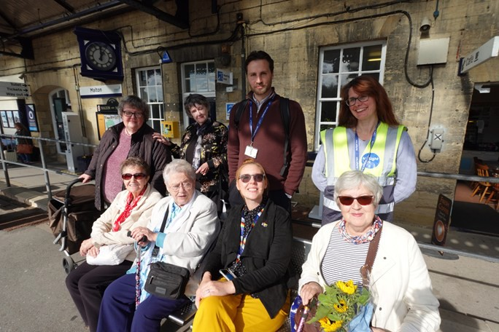
MySight York consultants on the platform with Rob Walker

The day gave participants the opportunity to take a journey with TransPennine Express (TPE), covering everything from booking assistance to boarding the train and navigating the station with support.
First time and long-absent returning
passengers to York station trialled the booking of assistance 20 minutes in advance of travel and were encouraged to use the 'National Rail Assistance' line for advanced bookings, who can be contacted on 0800 0223 720.
We then alighted at the WhistleStop Cafe in Malton Train Station to answer consultation questions for TransPennine Express, who were able to take away positive comments and considerations for improvements to the service and refer on to appropriate providers.
One of the MySight York passengers said:
'It gives us confidence. You point us in the right direction. It's not MySight York doing it for you, it's the organisation giving us confidence". In this instance, giving us the confidence to ask at the train station information desk. I'd ask any of the staff now, where I wouldn’t have done before. I now realise that people don't necessarily know your needs and
that sometimes, you need to state
what they are".
Danielle Colcombe, Accessibility and Transport Integration Manager, TransPennine Express said:
"It was great to see so many people building confidence and discovering just how accessible rail travel can be when we work together"
Thank you to Danielle and Rob Walker, Interim Accessibility and Equality Impact Officer for such an opportunity.
16

MySight York Sight Loss Friendly in York status recipients.
The aim of Community Connect is to work with local organisations to make the service or activity they
offer more accessible to people with sight loss. The following organisations have taken part in consultations with members of the project and have now been awarded Sight Loss Friendly status.

Cuppa and a Chorus, National Centre for Early Music
Dr Christopher Roberts, Operations
Manager at NCEM said:
"One of the National Centre for Early Music's core values is that we are welcoming to all. We are always looking to diversify our outreach and engage with new audience, so it was fantastic to celebrate our Sight Loss Friendly status with our partners MySight York, at our first Cuppa and a Chorus session this Autumn. Well done and thank you to all our events team, our fabulous
workshop leader Chris Bartrum and
of course, to MySight York for all the support throughout this process".
If you would like to join the sessions as a member, places are limited. Please contact hello@mysightyork.org If you are a member of the public, outside of our organisation and wish to join the sessions, please visit the
NCEM website: www.ncem.co.uk/
cuppa-chorus/

Holy Trinity Church, Goodramgate, Churches Conservation Trust
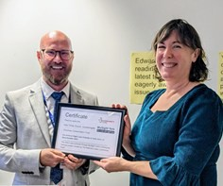
Scott Jobson presenting Gemma Murray with the Sight Loss

Gemma Murray, Holy Trinity Church, Goodramgate said:
"Very proud to have received our Sight Loss Friendly Award from MySight York. Working towards this has been an absolute pleasure as well as an education. Really grateful to the staff and volunteers who have helped us along the way. We will keep thinking about how we can improve access and make our welcome a little warmer for everyone".
If you would like to book on one of their future Sensory Tours or simply visit as an individual to state you needs, please
contact york@thecct.org.uk

As the festive season warms up in York, it is the perfect time to get out and about, enjoy the sparkle of twinkling lights, festive cheer, and a family show or two. This year, two much-anticipated pantomimes are lighting up the city’s stages with inclusive performances that
Out and About at Christmas in York
highlight accessibility.
First up is the glorious production of Cinderella at the Grand Opera House York, running from Saturday 6 December 2025 to
Sunday 4 January 2026.
This show brings together a dazzling cast, including Lisa George as the Fairy Godmother and Tobias Turley as Prince Charming, to tell the familiar story of the ball, the fairy godmother and the pumpkin coach, all with plenty of laughter and sparkle.
There will be an audio described performance on Monday 29 December 2025 at 5.30 pm, including a touch tour for visually impaired audience members. If you are looking for a joyful and inclusive outing, this is a great option.
Access tickets can be booked by joining the Access Membership Scheme on 0333 009 5399 or visit atgtickets.com/access/contact-us
Over at York Theatre Royal, the enchanting pantomime Sleeping Beauty runs from Tuesday 2
December 2025 to Sunday 4 January 2026. With fairy magic, princes and plenty of festive fun, it is a treat for all ages.
Access provision includes an audio described performance on Monday 29 December at 5.30 pm, with a touch tour at 4.00 pm. There will also be BSL interpreted, captioned and relaxed performances at other times. This means that if you are looking for a pantomime that goes the extra mile to be accessible, this is an excellent choice.
For bookings call 01904 623568.
If you are travelling a little further afield, Northern Ballet’s production of The Nutcracker tours to Leeds Grand Theatre from Thursday 18 December 2025 to Sunday 4
January 2026. The audio described performance takes place on Saturday 3 January at 2.00 pm, with pre-show notes from 1.45 pm and a free Touch Tour Insight earlier in the day.
To book contact the access line on 0113 2053899.
Whether you go for Cinderella, Sleeping Beauty or The Nutcracker, you will find magic, music and laughter in abundance.
Wrap up warm, book your tickets early, and enjoy a wonderful festive outing.

MySight York’s tree at York Minster
MySight York Festive Celebrations
We are delighted to have been invited to decorate a tree again this year, at York Minster’s Christmas Tree Festival. There will be 70 trees on display. The theme of our tree this year is “Bigger, Brighter, Bolder” - which celebrates how simple adaptations can make a significant difference to people with sight loss. Decorations have been made by the extremely talented members of our Knit and Natter
group. The festival will run during
sightseeing times until Monday 5th January, admission is free for York residents with proof of address.

We’ve decorated Sarah Scott’s room at Treasurer’s House
Our Knit and Natter group have been incredibly busy, as they’ve also made items to decorate Sarah Scott’s room at Treasurer’s House. 15th November – 21st December, Saturday to Wednesday, 11am – 4pm (last entry 3.30pm).
Below is a snippet from the information board which is included in the room:
“Sister of Elizabeth Montague, Sarah Scott lived for a time at Treasurer’s House. A novelist, translator, and member of the famous Bluestocking circle of intellectual women, she used her writing to imagine a fairer, more
compassionate society. Inspired by Sarah’s story of community and creativity, the
MySight York knitting group have created the wonderfully knitted decorations you can see in this space.”
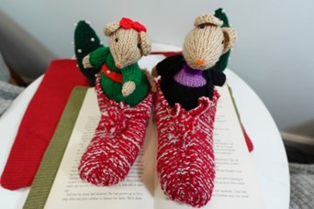

Upcoming stalls this Christmas:
Festive Knitting and Handmade Cards stall at New Earswick Folk Hall’s Festive Fair. Saturday 29th November, 11am – 3pm. New Earswick Folk Hall, YO32 4AQ.
Festive Knitting, Handmade Cards and Information stall at York Hospital. Friday 5th December, 9am – 2pm. Located at The Hub, in the entrance to Ellerbys restaurant.
Festive Knitting and Handmade Cards stall at Holy Redeemer Christmas Tree Festival. Saturday 6th December, 12 – 4pm. Holy Redeemer Church, 108 Boroughbridge Road, York, YO26
6AB.

Invitation to the Christmas Party


Celebrate Christmas with MySight York
We are please to announce our Christmas party:
Time : Tuesday 16th December 12.30-2.30

Venue: Patch York, in the Bonding Warehouse where Terry Avenue meets Skeldergate, York, YO1 6FA

This event is free to attend.

There will be food, drink, fun and laughter to celebrate the Christmas season, as well as a raffle and Christmas quiz.

Spaces are limited so please let us know if you would like to attend. To book:
Call: 01904 6362969
email hello@mysightyork.org

If you book a place and find you are unable to attend please let us know so your place can be offered to someone else.

Patch is accessible via ramp or steps and there is level access throughout the building. Staff will be on hand outside and inside the venue to meet and guide attendees.

