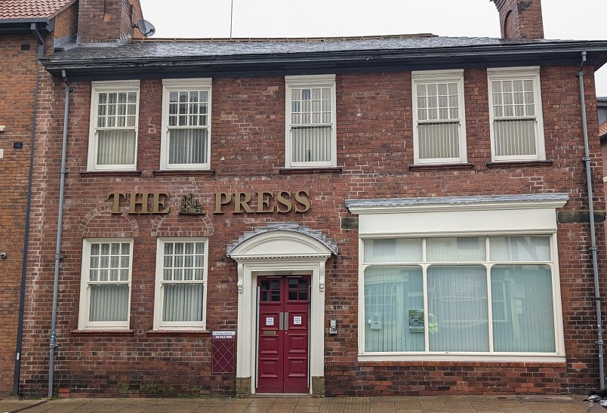
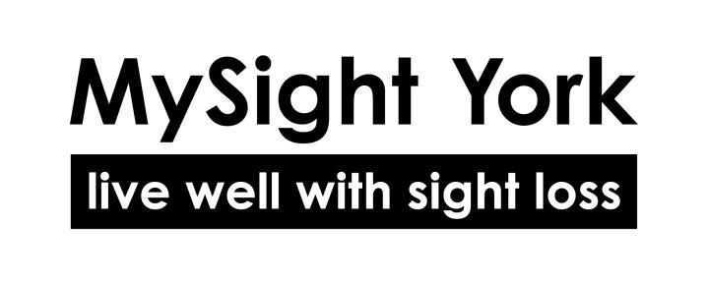
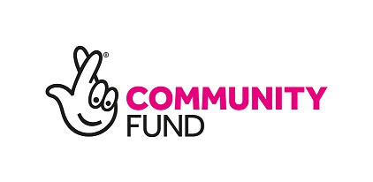


YorView
Reg. Charity No: 1159188
The newsletter of MySight York
Spring 2025

Welcome to our new home on Walmgate




From the Editor…
YorView
is the Newsletter of MySight York
Ground Floor 84-86 Walmgate York, YO1 9TL
Tel. 01904 636269

Email: hello@mysightyork.org

www.mysightyork.org

Chief Executive: Scott Jobson

www.facebook.com/ mysightyork

@mysightyork

www.linkedin.com/ company/mysight- york

YorView is published quarterly.
It is available in large print,
braille, audio (USB or CD) and at www.mysightyork.org

Editor: Barbara Fairs

Hello and welcome to our first newsletter of 2025 and we can now bring you the long-awaited news of moving into our new home. See pages 4 and 5 including an invitation to our Grand Opening in April.
Helen and Karen give us an
update on the support available at York Hospital and the Community Stadium on pages 10-11.
Vicky has news of how to get involved with the National Lottery funded Community Connect Project to make York a “Sight Loss Friendly” city (page13) and there is an opportunity to get involved with the York Festival of Ideas (page 8).
Bex tells us about her recent experience using the Passenger Assistance app for train travel along with 7 top tips to stay safe online on pages 15-17.
There is an update from the Chair regarding next steps of our Governance journey (page 14)
and Louise gives us all the latest
fundraising news (page 18-19).
There is also an invitation to a Vision Zone Open Day in our new premises on 26th March which will be a great opportunity to check it out and see the latest tech (page 20). See you there!
Barbara

- From the Chief Executive Scott Jobson updates us on the new premises
In this issue

Invitation to our Grand Opening

- News in Brief
  - Befriending Service
  - York Macular Group
  - Easingwold Macular Group
  - St Chad’s Tea Concerts

News in Brief contd.
  - Think Pharmacy First
  - Accessibility Help
  - Office Closure Dates

News in Brief contd.
  - Festival of Ideas
  - World Book Day 2025

Sight Loss Awareness Training
Vicky Smith tells us about training in the community

Our Triangle of Support
An update of the services we run in 3 locations across the city

12 Update on Regular Activities Lydia Wrightson runs through the current activities

13 Help us to Make York “Sight Loss Friendly”
Find out how to get involved in the Community Connect Project

14 Next Steps on our Governance Journey
An update from John Sole and
Scott Jobson

15 Tech Tips
  - Passenger Assistance App
  - British Wireless for the Blind

16 Online Safety
7 tips for online safety

18 Fundraising News
An update from Louise Calpin

20 Vision Zone 2025
An invitation to find out more about assistive technology

From the Chief Executive

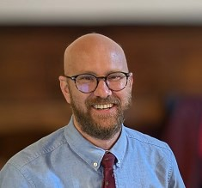
Our Exciting Move to The York Press Office
I am delighted to share the fantastic news that we have officially moved to our new home at The York Press Office on Walmgate. This marks a significant and positive step for our charity, one that will allow us to better serve our community.
First and foremost, I want to extend my sincere thanks to each and every one of you for your patience, support, and goodwill throughout this transition.
We understand that moving premises can be an uncertain time, requiring extensive work and legal considerations, and we deeply appreciate your understanding as we navigated this process. And although the move took longer than expected, we are thrilled to be settling in to our new space.
Our new premises, on the ground floor at The York Press Office offers an accessible, welcoming, and modern space right in the heart of York. Our central location means
that we continue to be conveniently
situated, making it easier to drop in, attend appointments, and participate in our wide range of activities and services. The improved accessibility of the building ensures that everyone who visits us can do so with comfort and ease, which is at the very core of what we strive to achieve as a ‘Visibly Better’ accredited organisation.
The new premises provides us with an efficient and functional space
that allows us to continue to offer the high-quality support, advice, and guidance that our members rely upon.
Furthermore, the move demonstrates our responsibility to our donors, ensuring that their generous contributions are used efficiently and effectively to enhance the services we provide, underscoring our commitment to making the best use of our resources.
The adaptations that we’re making before we ‘officially’ open have
been designed with accessibility at the very core, with features including clear, high-contrast signage throughout the premises, step-free access, with all essential facilities located on the ground floor. Additionally, the building boasts accessible toilets and spacious activity areas designed to provide comfort and ease of movement.

I would also like to take a moment to extend a special thank you to Barbara Fairs, who has worked tirelessly alongside me to make this move as smooth as possible. Barbara’s dedication, attention to detail, and unwavering
commitment have been instrumental in ensuring that this transition was handled with the utmost care and efficiency. Her efforts have not gone unnoticed, and we are all deeply grateful for her hard work and support.
We also want to express our heartfelt gratitude to The York Press for being so accommodating throughout this process. From the very start, they have welcomed us with open arms, and we look forward to a long and successful partnership with them.
Our new home however, is more than just a change of address; it is an opportunity to grow, to enhance our services, and to create an even stronger community as we go forward with a new strategy and invigorated ambition.
Read on for how and when to come and visit us, to explore the new space, and to see for yourselves how this move benefits everyone involved with supporting people with sight loss in York.
Thank you again for your unwavering support. We are excited for this new chapter and for all the possibilities it brings. We look forward to welcoming you to The Press Office very soon!

Join us for the Grand Opening
We are excited to announce that
our doors will officially open on
10th March for visitors, members, and appointments.
This opening day is the perfect opportunity for you to:
- Explore the new premises.
- Familiarise yourself with the improved facilities.
- Experience the many benefits
that this move has brought.
- Attend an appointment or group session in the new space.

Key Dates:
- 10th March – Official opening for visitors, members, and appointments.
- 10th April (11am – 1pm) – Grand Opening Ceremony with refreshments.
In addition to our initial opening, we are thrilled to invite you to our Grand Opening Ceremony on 10th April from 11am to 1pm.
This special event will be a chance for us to celebrate this exciting new chapter together. There will
be refreshments and time to acknowledge the hard work and dedication that has gone into making this move a reality.
We would be delighted if you could attend and share in this special moment with us. Your
support has been invaluable, and we look forward to celebrating this new beginning together. We hope to see you there!

Befriending Service—A friendly
face
If you feel you would benefit from having a friendly volunteer visit you at home for a chat or to help you
get out and about then please get in touch as we have some trained home visitors waiting to be matched with a client. To find out if the home visiting service is for you, please get in touch with Catherine on 01904 731122.
York Macular Society Group Meetings are held on the third Thursday of every other month from 20th March, 1-2.30pm at St Sampsons’s Centre on Church
Street.
Come along to share experiences and make friends over tea and a chat. Also open to people with any sight loss condition. Please bring
£2 towards room hire.
Contact Vicky Thompson on 07376 398916 for more information.

St Chad’s Tea Concerts 2025
News in brief
Thursdays at 2.30 pm
About 45 minutes of classical music, followed by tea and cakes. Free entry, donations appreciated! These are dementia-friendly events, everyone welcome!
20 March: Molly Raine contralto, David Hammond piano
17 April: Jenefer Townsend flute
22 May: York Guitar Quartet
19 June: Patrick Wilson trumpet, Maria Marshall cello, Robert Gammon piano
17 July: Flauti Felice flute
ensemble
St Chad’s is at 36 Campleshon Rd, York, YO23 1EY.
There is a small car park, and roadside parking nearby.
Disabled access via Hall. Enquiries: Alison Gammon, 07914 671620.

Easingwold Macular Group
This group now meets at the Olive Branch, Market Place, Easingwold in a room at the back of the café, opposite to the front door.
Meetings will be held 10.30-12.00 on the following dates:
- 14 April 2025
- 12 May 2025
- 09 June 2025
- 14 July 2025
- 11 August 2025
- 08 September 2025
- 13 October 2025
- 10 November 2025
- 08 December 2025
If you would like to know more about the group then please
contact Vicky Thompson, Regional Manager for the Macular Society on 07376 398916 or email
vicky.thompson@macularsociety.or g


Office Closure Dates

MySight York will be closed on the following dates:

From 3pm on Thursday 17th April until 9am on Wednesday 23rd April

Monday 5th May Monday 26th May


Think Pharmacy
First

If you have sinusitis, shingles, a sore throat, earache, impetigo, infected insect bites or a UTI, your pharmacist can help.
Pharmacists can now provide treatment or some prescription medicine, if needed, for seven
common conditions, without you
seeing a GP.
Don’t wait for minor health concerns to get worse – think pharmacy first and get seen by your local pharmacy team.
Subject to age eligibility. Service available at majority of pharmacies.
Find out more at
nhs.uk/thinkpharmacyfirst
Help Us Help You—See your pharmacist.

Accessibility Help
AccessAble is an online Accessibility Guide available via the website https:// www.accessable.co.uk and through an App on your phone or tablet.
The guide lets you know what access will be like when you visit somewhere, such as the route you will use getting in and what is available inside and there are many community and commercial locations and walking routes in York available on AccessAble.
Euan's Guide is a disabled access charity where you can find and share disabled access information.
Many smaller organisations are featured and you can leave your own review of access at a community venue in York.
For more information got to www.euansguide.com/
call 0131 510 5106 or email hello@euansguide.com

MySight York, Community
Connect working with the York
Festival of Ideas
Join archaeologist and broadcaster Julian Richards for an artefact- handling workshop and experience the past through a range of senses.
Archaeology is all about people like us – it’s a way of finding out about their lives through the objects they left behind. During the session, you’ll examine objects from prehistory to comparatively recent times, and explore how they were made and used, and the stories they might tell.
Come along as we bring the past to life through touch, sounds and even smells!

About the speaker
Julian Richards is an archaeologist and broadcaster who has devised and taught many courses for the visually impaired. He specialises in
the prehistory of Britain and has a long-standing involvement with
Stonehenge. He has directed major fieldwork projects and worked in both commercial archaeology and for English Heritage before a career change to broadcasting and education. Julian presented programmes for the BBC, both on TV (Meet the Ancestors and Blood of the Vikings on BBC2) and on radio (Mapping the Town on Radio 4). Julian is passionate about bringing the past to life and is involved in writing, devising and delivering community archaeology projects, working with schools, making non-broadcast film and curating museum exhibitions.
The event will take place at Friends Meeting House, York on 2nd June 10:30 – 11:30am.
If you would like to attend then please contact Vicky Colombi Vicky.colombi@mysightyork.org or call 01904 731124.

World Book Day 2025
World Book Day is a celebration of reading for children and young people that takes place in March every year to give them access to low cost or no cost books.
There is a range of books available for beginners, early readers and
fluent readers such as Bluey’s Little Book, The Adventures of Paddington:Farm Escape and The Soccer Diaires: Rocky takes the
Lead.
Braille and audio versions will be available for all of the World Book Day books on the list. Families and young people with a vision
impairment can order their copy from
the RNIB Helpline on 0303 123

9999 from Thursday 15 February.
Any large print books can be requested through Guide Dogs CustomEyes service. https:// www.rnib.org.uk/living-with-sight-loss/ independent-living/reading-and- books/world-book-day/

Vicky Colombi updates us on recent training courses

MySight York is offering free
Sight Loss Awareness Training

Bespoke Sight Loss Awareness and Sighted Guiding and
Bespoke Social Media Accessibility Training to
Community Organisations until December 2025, as a part of the Community Connect Project (funded by The National Lottery Community Fund).
Priority is given to organisations and businesses (with a local, social focus) who wish to fully sign up to become a part of the Community Connect Project. For more information, please contact Vicky Colombi
vicky.colombi@mysightyork.org
In late 2024, MySight York offered two separate multi-agency Sight Loss Awareness and Sighted Guiding Training Days.
Our members had previously expressed the desire to have more walking experiences, particularly slowed paced in the centre of York in parks and gardens. The York Conservation Trust signed up to the project with a keen interest in increasing the accessibility and awareness of their garden, St Anthony’s Sensory Garden, in the
heart of the city. They kindly hosted
and participated in the first multi- agency training day, they were joined by their tenants and
contractor, Pinnacle Conservation, United Response and the Council for British Archaeology.

“A relatable introduction into life with sight loss and how to assist someone with a visual
impairment”
Our members had previously expressed the need to feel safe within the city. We approached York BID Street Rangers, who then had a strong interest to join the project. As part of York Disability Week
2024, York BID kindly hosted and participated in the second multi- agency training day. The York BID Street Rangers were also accompanied by the following organisations and companies, City Screen Picturehouse, Shopmobility York, National Centre for Early Music, Ambiente Tapas, York Museums Trust and Make it York.
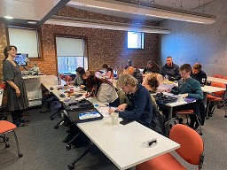
“Friendly, informative and full of important and interesting information”

Helen Flett and Karen Dransfield update us on all the ways our Sight Support Services can help you

Being diagnosed with a sight condition can be difficult to come to terms with and everyone reacts differently. It can be a challenging time both practically and emotionally. That’s why the Sight Support Service is here to support you.
Our Triangle of Support
MySight York offers a triangle of
support which spans York Hospital, the Community Stadium eye clinic and our city centre headquarters
offering seamless accessible support for patients on their eye
care journey. The triangle includes our two clinic-based services, the Eye Clinic Liaison Officer (ECLO) and the Sight Support Advisor who together, support patients through the Eye Care Support Pathway.

Eye Clinic Liaison Officer (ECLO)
Helen Flett, ECLO, is based in Area A of the Eye Clinic at York District Hospital, Wigginton Road, YO31
8HE.
Helen works directly with over 500 patients each year who have a diagnosed sight condition.
Through face to face and telephone appointments she helps to bridge
the gap between clinical diagnosis in the hospital and services in the community, providing information, advice, emotional and practical
Helen Flett
support. Helen can signpost and refer to relevant services within the patient’s local community that can provide ongoing support to live well with sight loss.
In addition, Helen supports eligible patients through the 2-stage certification and registration process.
Stage 1 – Certificate of Vison Impairment.
Stage 2 – Registration under the local authority

The ECLO service operates Monday to Friday, 9am – 4pm.

Contact details
Helen Flett
Telephone: 01904 721 858 Email: helen.flett3@nhs.net
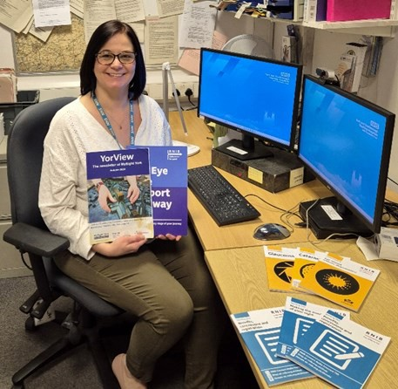

Sight Support Advisor
Karen Dransfield, Sight Support Advisor, is based in the Sight Support Office, (directly opposite the injection rooms), at the Eye Clinic, 1st floor, York LNER Community Stadium, Kathryn
Avenue, Huntington, YORK, YO32 9JS.
This service started in November 2024 and was developed as the number of patients attending the stadium eye clinic has increased – in 2024 approximately 4,000 individuals attended and 16,000 appointments were offered.
Karen offers face to face and telephone appointments and follow ups as required. Where possible these are scheduled to coincide when patients attend the eye clinic, sometimes these can be undertaken as drop-ins. Patients can refer themselves, but most referrals are received from staff within the eye clinic.
She can help with understanding your diagnosis, managing the emotional impact of sight loss, helping you maintain independence and confidence with everyday tasks, signposting to advice on employment and benefits and demonstration of equipment / assistive technology that may
support with daily living tasks.
Karen offers advice, signposting and makes referrals to MySight York and other sight support services, sensory teams and
external organisations as appropriate.
Karen cannot undertake the certification and registration process, but she refers onto Helen Flett (ECLO) as needed.
The Stadium Service operates Tuesday to Friday 9 - 4PM

Contact details
Karen Dransfield
Telephone: 01904 724116
E:mail: karen.dransfield1@nhs.net
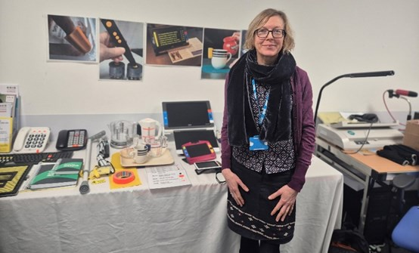

Karen Dransfield

City Centre Premises
Completing the triangle of support is our city centre premises where we can provide ongoing support in an accessible, community-based environment.
Here, we offer in-depth assistance, including specialist equipment and information from Deb and Bex in the E&I Centre as well as counselling, befriending, social activities, and training, all aimed at enhancing independence and quality of life.

By Vicky Smith and Lydia Wrightson

Coffee Morning Discussion Group: Face to face.
Regular activities
Coffee Morning Discussion Group: Telephone only
Support with MySight: Face to face on the first Monday of every other month.
Telephone Speakers Group: first Monday of every other month. (occasionally face to face)
VI Tennis: Run by a York Disability Tennis Network qualified coach, held at the University of York, York Sports Centre. Weekly, every Monday. 11:30am - 12:30pm.
Telephone Quiz: Last Friday of the month. 3pm - 4pm.
Audio Book Group: First Tuesday of the month. Telephone Only.
10:30am - 11:30am. (at present, telephone only)
Chair-based Tai Chi: Run by UK Tai Chi Betty Sutherland. Monday mornings from 11.40am to 12.40pm.
Accessible Board Games Group: 11:40am – 12:40 Weekly on Thursdays.
Chair Exercise: Run by Xercise Haxby at MySight York. Weekly, every Thursday. 10:30am – 11:30.
Knit Natter: A friendly group who meets for a chat and knitting at MySight York. Face to face.

Register your interest for the
following once a month groups Cuppa and a Chorus – Integrated Singing Session at The National Centre for Early Music Monday with MySight York Volunteers and large print/braille lyrics (however, most music learnt by ear). Once a month Mondays 2pm.
Blind Golf Session at York Golf Club, potentially to start once weather warms.
If you are interested in joining any of our groups please contact Lydia on 01904 731128 or email:
lydia.wrightson@mysightyork.or g

Save the Date
Living Well with Sight Loss Course
Offering you the opportunity to meet other people who may be new to sight loss or experiencing
recent changes. You’ll get practical advice, information and guidance on organisations, products and services. Two day course
Save the date: 21st and 28th March 2025

For more information contact vicky.colombi@mysightyork.org or call 01904 636 269.





Wonderlab’ at the National Railway Museum, ‘Aromalabs’ Coffee Tasting Workshop and commented on his experience of the ‘Shared


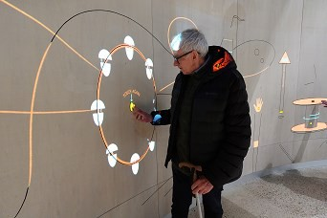
Bob at the Wonderlab

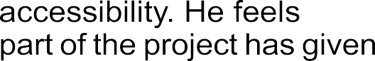
Bob tells us that being part of the project has given him a new perspective and he now can’t

If you would like to become a MySight York consultant with lived experience of sight loss and have your say about the accessibility of a venue or activity within York, register your interest for the following ‘focus group, sessions with
lydia.wrightson@mysightyork.or g

Arts and Humanities
- Sight Loss Saunter at St Anthony’s Sensory Garden and Thin Iced Press, York Conservation Trust and Thin Iced Press
- Slow paced walk with the
Haxby and Wiggington U3A
- Tour of York Mansion House

Health and Wellbeing
- Stamford Bridge Tapestry’s Tour
- York Festival of Ideas – Archaeology Item Discovery Event

Children and Young People’s
- Adapted Cycling Sessions for
children and young people
- Storytelling Sessions for children

Technology
- Vison Zone York 2025 - Assistive technology, Support, Services and Groups Exhibition

John Sole and Scott Jobson invite you to share your views

In our August 2024 newsletter John Sole, Chair of MySight York, outlined plans to make some changes to our Constitution to help the Trustees be more responsive to potential opportunities that would benefit the charity and make it more resilient to future challenges.
Next steps on our Governance Journey
At the following Annual General Meeting (AGM) in November, the motion to transition MySight York to a Foundation Model governance structure was not carried, despite receiving a majority vote. The proposal, which aimed to streamline decision-making and enhance our ability to respond swiftly to opportunities, required a higher threshold for approval under our constitution.
We understand that the low level of engagement during this process reflects the need for deeper dialogue and more inclusive discussions about our governance and future direction. Your voices are crucial in shaping the path forward, and we are committed to ensuring that every member has
the opportunity to participate meaningfully.
To that end, we will be hosting a series of engagement and consultation events throughout
2025. These sessions will provide opportunities to discuss the challenges and restraints posed by
our current constitution and explore solutions that align with our shared vision for MySight York.
The events will include in-person gatherings, listening events, virtual meetings, and written consultations to accommodate all members, ensuring accessibility and inclusivity. Whether you’re passionate about preserving our Associate Model or curious about
the potential benefits of a Foundation Model, your input will guide our next steps.
We are also working closely with
the Charity Commission to ensure that any changes we consider are both compliant and in the best
interest of our members and the wider community.
Thank you for your continued engagement and commitment to MySight York. Together, we can build a governance structure that empowers us to thrive while staying true to our values. Details of the consultation events will be shared soon - please look out for updates in future newsletters, emails, and on our website.
Your input matters, and we look forward to hearing from you. If you have any queries in the meantime please contact scott.jobson@mysightyork.org or call 01904 636269.

By Bex Wood
Tech Tips

Passenger Assistance App
I wanted to write about my recent experience with the passenger assistance app for train journeys.
The app is free and available on both Android and Apple. The app is easy to download and asks for you to create an account. This required minimal personal information and information about any disabilities
that may impact your journey. There is the option to change the theme of the app for those who find some colours better than others as well as the app working with your phones own accessibility features.
In order to book assistance you will need to book your train tickets through your usual methods.
Once you have the details of your journey you can go onto your passenger assistance app.
Once in the app you will see a box asking about your journey, Click in the box and type in your ‘From’ and ‘To’ station and the times of your
train.
This will bring up the trains available from the information you input. Find your train from this list.
Once you have selected the correct train the app will ask you what assistance you may need, you simply click the boxes that

relate to the support you will need. There is also a box for more information, including your seat information if you need help to your seat.

British Wireless for the Blind
Fund – exciting new partnership
British Wireless for the Blind Fund are excited to announce a groundbreaking partnership with VICTA, a national charity that provides support to children and young people. The partnership will provide accessible technology for those aged 0 – 29 years old. The initiative will provide cutting edge devices to support young people with sight loss in their daily lives, education and help with social connectivity. The technology that will be available includes Alexa smart speakers, voxblock players and Morphee sleep aids. The partnership will make these devices available through VICTA’s established networks and support systems.
For more information about the partnership and how to access the support please contact: infor@blind.org.uk or kallie@blind.org.uk,
or call 01622 754757
For more information on VICTA: https://www.victa.org.uk/,
Call 01908 240831.
15

Bex Wood sets out some guidelines for staying safe online

11th February 2025 was Safer
Online Safety
Internet Day and everyone is aware that there are many different scams that can target people by email or text.
We want you to be safe when using online services. A couple of things to keep in mind is: if you have not entered anything you cannot win anything, anything
asking for details to pay you money is a scam, Government organisations will never text or email you asking for details. A couple of common scams are:
- A relative claiming to have lost/ damaged their phone or they need money and the number they have messaged from is a new number. In this case, ignore the message, if you are worried, you can always call the relative in question on the number you have for them
NOT the “new” one.
- You may receive a text message or email claiming that there has been a failed delivery at your home and that you may need to click on a link to provide more information or to pay a fee. DO NOT click on the link or provide any further
information.
- A text claiming to be from your bank stating that there has
been a large transaction
attempt on your account and
asking you to call a number for more information. Again, do not reply or call the number but you can check your own online banking or call your bank direct on a number from an official
source.
If you are unsure, do not reply to messages from unknown senders. Here are some tips to keep you safe when using online services.
- Password Safety
Always keep your
passwords secure, never store them in your phone and use a different password for every account. Never store your bank PIN numbers on paper in your wallet either.
Strong passwords are a good way to keep your account safe. A good way to create a strong password is to combine 3 completely different words together, Like: “Catcucumberweight”. Sometimes A password may require numbers or special characters, so you can substitute letters for numbers, so instead of “Cushion” use “Cu5h10n” which changes the s – 5, I – 1 and the o – 0, adding a special character can make a password stronger
Never reuse passwords as this is one of the main causes of hacking.

Another way to protect accounts is to enable Two Factor Verification. This is often done by sending a code to your mobile device in order to verify it was you attempting to access the account.
This gives you an added layer of
protection, as even if someone has your password they will be unable to get into your account without the second step being verified.
- Anitvirus/ Firewall
Having an antivirus program on your computer, tablet and phone can help protect it as it will detect harmful programs and viruses from infecting your device and protect you from having your activities tracked online. Examples such as AVG, Avast or Norton should be downloaded from a reputable place online a computer shop or an official site.
- How to spot scams?
Scams come in many shapes and sizes and can often look or sound legitimate. Some things to keep in mind when receiving emails are:
  - Never open or reply to an email from someone you do not know
  - If unsure about an email look at
the senders email address.
  - Never click on a link in an email from an unknown sender or
open an attachment.
- Never share personal details Do not give out any personal details such as: bank numbers, PIN’s, telephone numbers etc to someone you do not know or trust.
A company like a bank will never ask for these details to be given via email or text.
- Online Safety
When looking at websites, a way to check they are secure is by looking at the website address in the top bar. If the address starts with
https:// this is secure. Only download apps or software,
from an official site or app stores.
The official stores on these
are: Apple store, Google Play store and Android marketplace. Apps from these sites are verified.
- Updating Software
All devices from your PC and tablet to your mobile phone need to be kept up to date. Updates on these
often come with security updates to prevent theft of information and security breaches. Computers and mobile devices will often prompt you to update and Apps on your devices also need to be updated.
- Online Banking
If you are choosing to do online banking on your computer, tablet or mobile device, firstly make sure you only download the official banking app from a trusted official store (see 5 above). If using a website make sure the website is secure (see 5 above). Never share your password or PIN information to anyone. When finished using the website or app make sure you log out of the session to keep your account safe.

The latest fundraising news from Louise Calpin

Thank you
Fundraising News
A huge thank you to all of our knitters who contributed towards decorating our lovely tree at York Minster’s Christmas Tree Festival 2024! It was truly amazing how you all created such beautiful decorations. Many of the decorations from 2024’s tree will be available to buy on our fundraising stalls in the lead up to Christmas 2025. Thank you again!
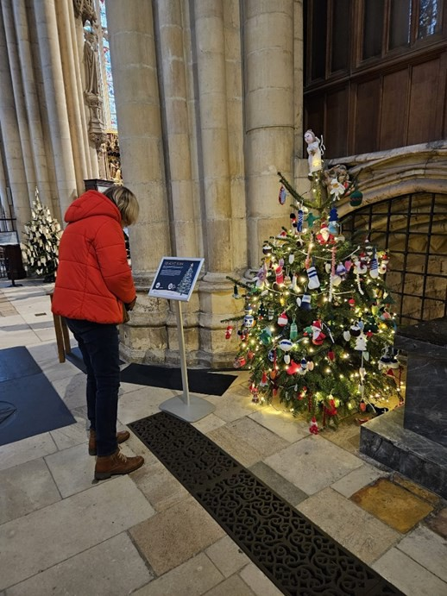

I would also like to thank the fundraising volunteers who helped with our fundraising stalls in the lead up to Christmas and thanks to those who came along to the events. Your support is greatly appreciated.

MySight York’s Spring Craft Fair
We are currently planning/ organising MySight York’s Spring Craft Fair, to raise funds to support the important services we offer, such as our Equipment and Information Centre.
Date: Thursday 8th May
Time: 12.30 – 2.30 PM
Venue: The Annexe Hall, St. Sampson’s Centre, Church St, York, YO1 8BE
MySight York will have a couple of stalls, and we’ll be inviting stallholders along also from local businesses.
Stallholders must pre-book their tables at a cost of only £10. Call us on 01904 636269 and ask for Louise, or email Louise.Calpin@mysightyork.org

Friends of MySight York – our new Facebook group
For those who use Facebook, we have created a new Facebook group called Friends of MySight York – Fundraising News. This is a space for our amazing community of people dedicated to supporting MySight York. The purpose of the Facebook group is to share updates about fundraising events, item donation requests, celebrate milestones, suggest ideas and

and connect as a community to make a difference. Request to join our Facebook group by visiting https://www.facebook.com/groups/ friendsofmysightyork or search on Facebook: Friends of MySight York – Fundraising News.

Items for tombola’s (particularly teddies and soft toys)
You can help us raise money by donating unwanted Christmas gifts you might have stored away. If you are thinking of having a clear-out, we would love your unwanted quality items for fundraising stalls, tombolas and raffles!
Examples of items we can accept: unopened beauty products and toiletries, chocolates, biscuits, sweets, candles, knitted items, teddies and soft toys, bags, bottles of shower gel/bubble bath.
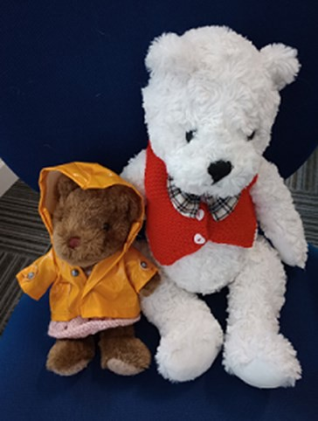

Due to the popularity of the Teddy Tombola last year, we are planning on hosting a couple more
throughout 2025.We would greatly appreciate donations of new or gently loved teddy bears and soft toys for our Teddy Tombolas! These cuddly companions will bring joy to lucky winners and support our fundraising efforts. Your contribution will not only add a smile to someone's day but also helps to raise vital funds.
You will soon be able to drop off items at our new location, however until we are fully opened it would be so helpful if you could start gathering item donations now in preparation!

Upcoming Stalls
Information Stall at Get Cycling CIC’s event – All Together Now (Inclusive Cycling and
Community Connections) – Monday 24th February, 11am – 2pm at York Railway Institute. Spaces are limited, registration is encouraged via Get Cycling CIC Eventbrite.
Information and Knitting Stall at York Hospital, The Hub (outside Ellerby's restaurant) – Friday 30th May, 9am – 2pm

If you, or someone you know, would like to raise funds on our behalf or if you have ideas/ suggestions, then please contact Louise on 01904 636269 or email louise.calpin@mysightyork.org and we will be happy to support you.

Invitation to Vision Zone 2025

Vision Zone 2025

Solutions for Low Vision

Would you like to find out more about assistive technology, as well as the services, groups and activities run by MySight York?

No matter what your sight loss condition we are here for you. Whether it’s just to gain knowledge or hands on
experience of new technologies, entry is free to our events,
and our friendly staff will greet you with a warm welcome.

Come along to our drop in day with

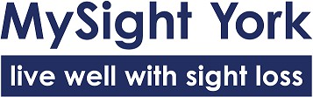
84 – 86 Walmgate, York, YO1 9TL Wednesday 26th March – 10 am to 2 pm

