Microsoft outlook Accessibility
Change type settings in Microsoft outlook in your mailbox.
- Along the top line of your mailbox select View
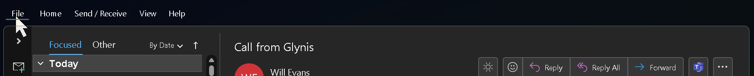
- Click on the drop-down arrow next to “current view”
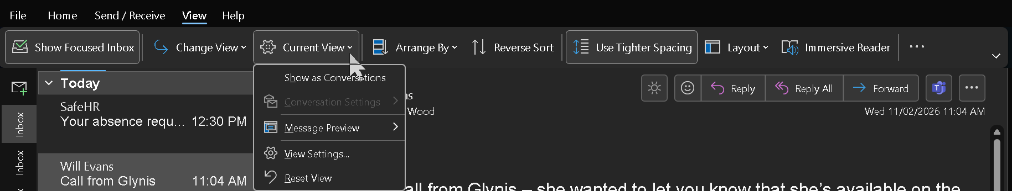
- Click on the option “View settings”
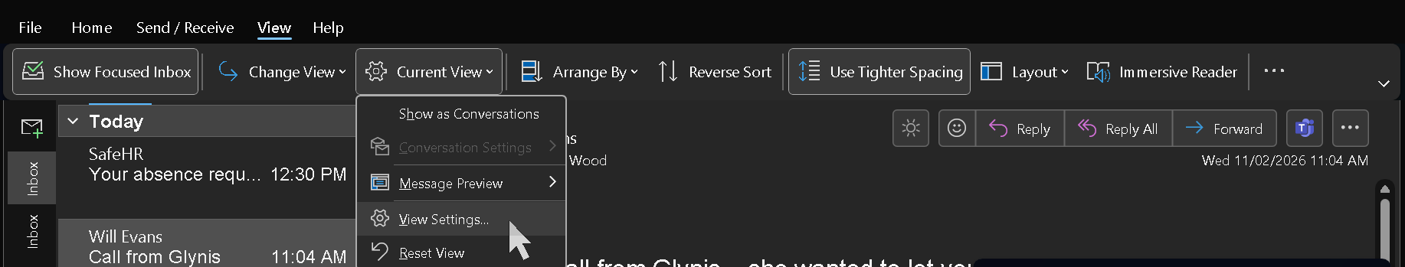
- Click the box which states “Other Settings” next to the text which says “Font and other table view settings”
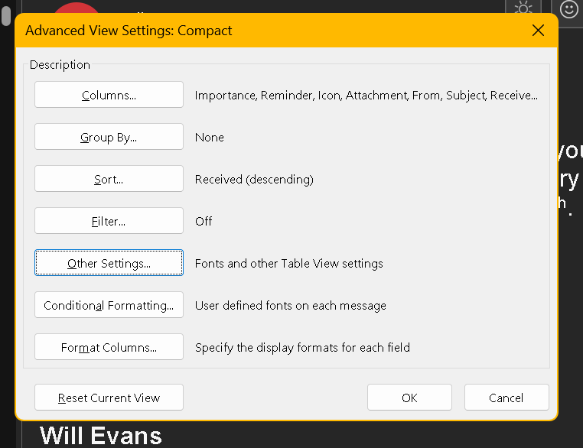
-From here you can identify the best font and size for you.
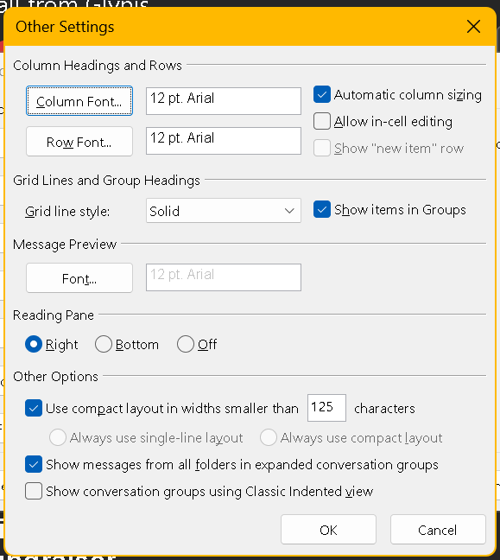
Once happy with the sizes select ok. This can be changed to suot your needs.
Same process can be completed for the Calendar in outlook

