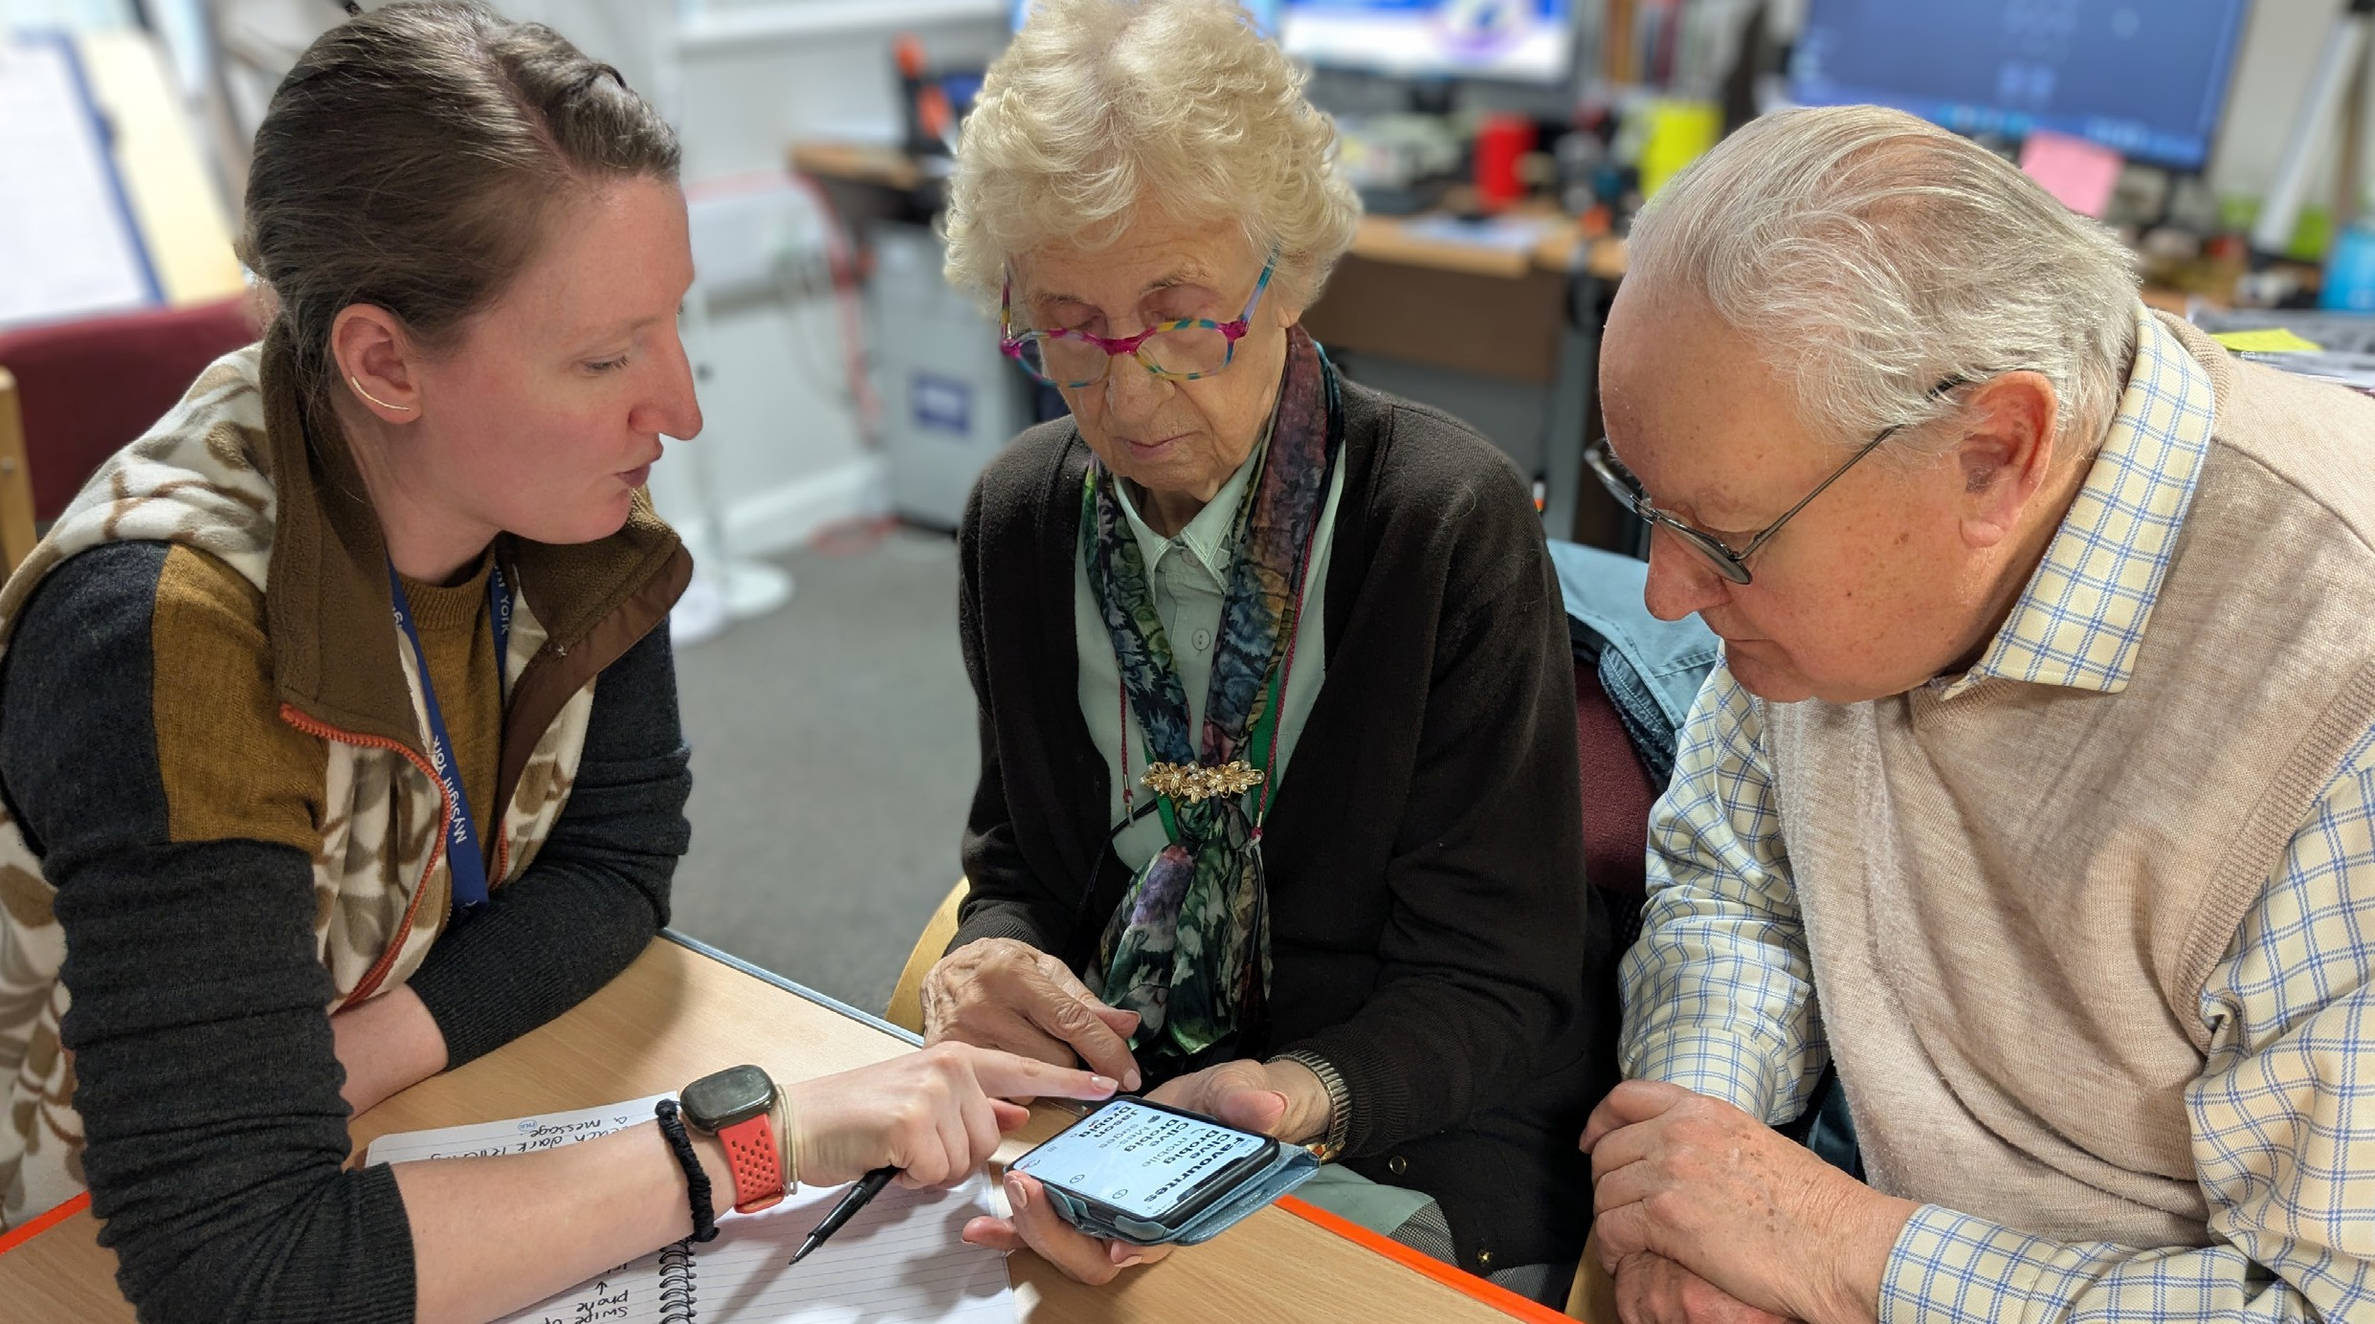
Summer 2026

Pictured: Digital Vision in action. See page 10 for more information.


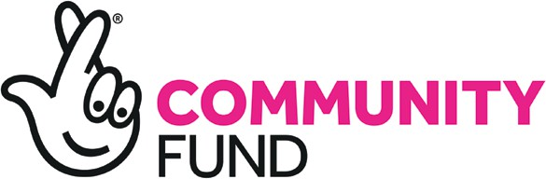
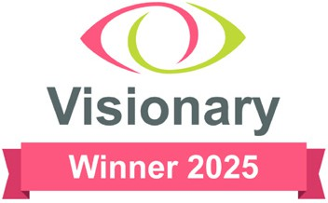










From the editor…

Hello - and welcome to the Summer edition of YorView.
Firstly, as you will see on page 4, we are saying goodbye to Scott after 6 years at MySight York. I’m sure you will all join me in wishing him all the very best for his future. On a personal level, I would like to say thank you for 6 unforgettable years, we will all miss you!
We have exciting news on page 10 about our new Lottery project, Digital Vision. As part of this we are also launching a new “Tech View” newsletter, with hints and tips for making the most of your technology. If you would like any help or advice in this area then please give us a call.
On page 12, Will gives us a update on fundraising activities and how you can play your part,, and Tanya has a spotlight on Megan, one of our fantastic volunteers on page 15.
One of our member’s, Paul, tells us all about the fabulous VI Tennis group and encourages others
to take part, whether you are a competitve player or just looking for some fun and fitness.
Finally, we have articles on pages 19 and 20 about the many ways you can receive this newsletter, including via our Alexa skill!
Barbara

4-5 From the Chief Executive
Scott Jobson gives the view from
the Chief Exec’s office

6-7 News in Brief
- Glaucoma UK
- Healthwatch Survey
- Grand Opera House - Audio described performances
- York Theatre Royal - Audio Described performances
- Office Closure dates

8 Regular Activities
A round up of regular groups and activities.

9 Special Projects - York Festival of Ideas
Vicky tells us about an interesting
upcoming one off event.

10-11 Special Projects - Digital Vision
Vicky talks about a new and exciting 4 year project.

12-13 Fundraising
Will shares an impact story from a member and talks about how MySight York is funded.

14 Volunteering focus
Tanya gives us an update on our volunteers.

15 Volunteering spotlight
Megan tells us about her experience volunteering for MySight York.

16-17 Equipment and Information
Deb recaps on some old favorites and updates on some new equipment.

Members Voice
Paul Hotchkiss talks about his experience of VI Tennis.

Alexa Skill
How to access MySight Yorks newsletter on Alexa devices.

Newsletter preferences
Barbara talks about the variety of formats the newsletter is available on. Including how many members the newsletter reaches.

3

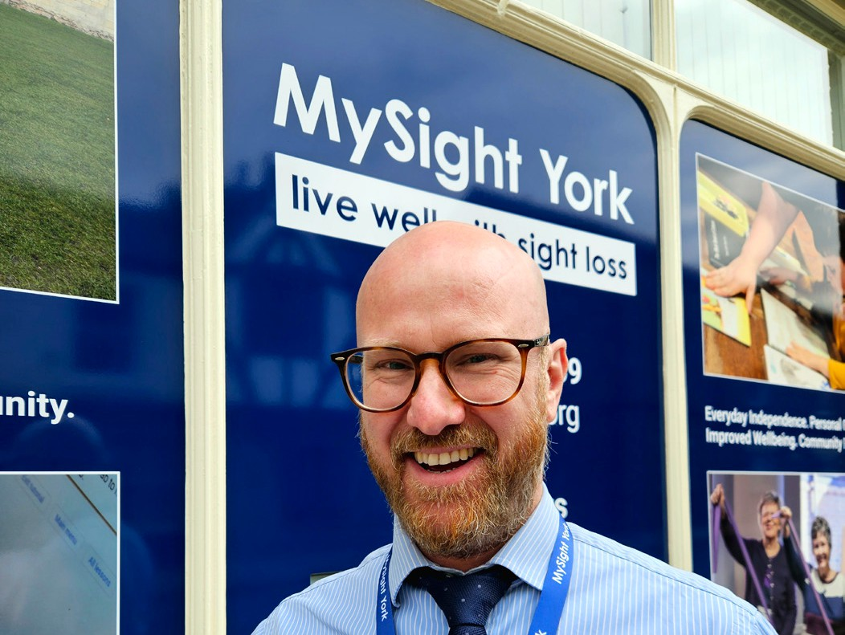
After Six Incredible Years: A Personal Thank You
After six years as Chief Executive of MySight York, and 16 years working within the sight loss sector, the time has come for me to move on to a new professional challenge.
This decision has not been an easy one. This organisation, and this community, have become a huge part of my life.
Before I leave, I wanted to personally say thank you.
When I look back over my time here, I honestly feel immense pride in what we have achieved together.
When I joined in 2020, none of us could have imagined the
challenges that lay ahead. Together, we navigated a global pandemic,
a cost-of-living crisis, growing pressure across health and social care, and significant changes in the charity sector. There were difficult moments, uncertain moments, and times when we had to adapt very quickly.
But throughout all of that, I never
lost faith in this organisation or the people behind it.
Instead of standing still, we transformed MySight York into a stronger, more ambitious, more resilient and more forward-thinking organisation than ever before.
Indeed, over the past six years, I’ve had the privilege of helping lead the successful delivery of a major National Lottery funded project,
as well as securing a further new National Lottery funding award to help shape the next chapter of MySight York’s work. During this time, we rebuilt our financial
reserves, including achieving two consecutive years of surplus, developed and launched a bold new organisational strategy, refreshed both the staff team and Board
of Trustees, expanded services and partnerships, strengthened digital support and community
activities, and moved into a modern, accessible headquarters in the heart of York.
I am also incredibly proud of the role MySight York has played locally, regionally and nationally within
the sight loss sector. Together, we helped shape, champion and lead the implementation of the Eye Care Support Pathway within the Humber and North Yorkshire Integrated Care Board, helping position the region as a national leader in this work. I also had the privilege of chairing and representing the Yorkshire Visionary regional group, while MySight York itself was recognised with two national Visionary awards for innovation and impact.

But most importantly of all, MySight York is now supporting more blind and partially sighted people than at any other point in its history.
That matters more to me than any award, title or project ever could, because beyond the strategies, funding bids and partnerships, what I will remember most are the people.
I will remember the conversations, the humour, the honesty, the resilience and the trust people placed in us during some of the hardest moments of their lives.
I have seen confidence rebuilt, friendships formed, independence regained, and lives changed through support, community and connection.
I also want to say how proud I am of the staff, volunteers and trustees. Their compassion, professionalism and commitment
to supporting people with sight loss has inspired me every single day.
They consistently go above and beyond, often quietly and without recognition, simply because they genuinely care. They are the best.
I truly believe MySight York is now in the strongest position it has ever been in.
The organisation has a clear strategy, stronger partnerships, improved financial resilience,
a skilled and passionate team, and a reputation for innovation, collaboration and quality. Most
importantly, it remains rooted in the voices and experiences of blind and
partially sighted people.
The Trustees have already begun the recruitment process for a new permanent Chief Executive, and importantly there are strong plans in place to ensure a smooth and
stable transition for the organisation. The Board has recognised the importance of continuity during this period, and Deputy Chief Executive Barbara Fairs will step into the
role of Interim Chief Executive. Barbara’s knowledge of the organisation, our members, services and partnerships is unparalleled, and I know she will continue to
lead with care, professionalism and commitment.
I am immensely proud to have been part of this journey.
While I may be moving on professionally, I will always care deeply about the sight loss community.
MySight York has an incredibly important future ahead of it, and I genuinely hope people continue
to champion, support and believe in the organisation as strongly as I always will.
Thank you for the trust, kindness, challenge and support you have shown me over the years. Leading this organisation has genuinely been one of the greatest privileges of my career, and I will always look back on my time here with enormous pride and gratitude.
My warmest wishes,
Scott 5


As part of Glaucoma Awareness Week this year which runs from June 28 to July 4, Glaucoma UK are launching a National Patients survey which will open in July 2026 with the aim to collect over 10,000 opinions. The responses

will be shared with NHS leaders, policy and decision makers and health care providers who deliver your care. Glaucoma UK want
to ensure that your experience influences not only what they do as an organisation but decisions about care across the UK
Help line 012333 648 170 Email helpline@glaucoma.uk
https://glaucoma.uk/national-patient-voices-survey/

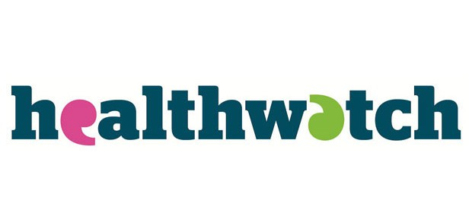
The survey is anonymous and comprises of 28 questions, some of which are multiple choice boxes whilst others require your thoughts and comments.

Healthwatch Survey

Healthwatch are running a survey to find out your views, knowledge and experience of some of the digital ways to access your health information, including the NHS app, GP online services or health apps on your mobile device. They are also keen to explore your thoughts of the use of artificial intelligence (AI) in healthcare.

You can complete the survey online at:
https://www.smartsurvey.co.uk/s/ DigitalHealth26/

If you would prefer a more accessible format, a hard copy of the survey or prefer to talk to
someone about your experiences, please call 01904 621 133 to
talk to someone, or email on healthwatch@yorkcvs.org.uk.

Audio described performances Grand Opera House
To book headsets call 0333 009 5399. No booking is required when using the mobile connect app.
Musicals
The Rocky Horror Show , Wednesday 22nd July 8pm
The Ballard of Johnny and June (the Johny Cash Musical)
Saturday 1st August 2.30pm Everybody’s talking about Jamie October 24th 2.30pm
We Will Rock You
28th November 2.30pm Plays
Paranormal Activity
Saturday 3rd October 2.30pm

York Theatre Royal
To book audio description and pre show touch tours contact
boxoffice@yorktheatreroyal.co.uk or
call 01904 623 568
Margaret Atwood’s The Penelopiad
Thursday 22nd Oct at 2pm(Touch Tour 1pm

Leeds Play House
To book call 0113 205 3899.

Brassed Off
Thursday 18th June - 11 July
Fireflies at dawn
24th - 25th June August Wilson’s fences 11th - 26th September
Peanut Butter and Blueberries 22nd October - 7th November
Dr Seuss’s How the Grinch Stole ChristmasThe Musical
19th November - 16th January Paranormal Activity
9th - 24th December

7

MySight York will be closed on the following dates: Monday 31st August - Bank holiday
Tuesday 1st September - Closed

We offer a variety of groups and activities, supported by our wonderful volunteers. Whether you prefer meeting in person or
by phone, we have something for everyone.
Support with MySight - If you’re new to sight loss, or simply need a supportive space, this group is for you. Meets every other month. In person only.
Esme’s Friends – Our support group for anyone who experiences visual hallucinations as a result of sight loss (also known as Charles Bonnet Syndrome). Monthly.
Hybrid Discussion Group or Telephone Discussion - Topics often include a thread connecting back to lived experience with sight loss. Alternates each month. Upon occasion, guest speakers are invited.
Accessible Board Games - run by MySight York volunteers, at the MySight York premises. Accessible dominos, cards, chess and much more. Weekly.
Knit and Natter - A friendly group for those who love to knit (and natter). Twice a month.
Audio Book Group - The group discusses a different book each session. Monthly.
Telephone Quiz - No prizes, just an enjoyable way to spend time with friends, old and new. The last Friday of the month.
Chair Exercise - run by Xercise Haxby at MySight York premises, supported by our volunteers.
Weekly.
Chair Tai Chi - run by UK Tai Chi via Zoom, at MySight York premises. Weekly. (This group is
currently full, please contact Louise to be added to the waiting list).
VI Tennis - run by a York Disability Tennis Network qualified coach, held at the University of York,
York Sports Centre. Supported by MySight York volunteers. Weekly.
VI Golf – Hosted at York Golf Club, players follow the same rules as all golfers, with a few minor adjustments. Booking is essential. Monthly.
Cuppa and a Chorus – Hosted at The National Centre for Early Music. Booking is essential.
Monthly.
If you are interested in joining any of our groups, or require further information, please contact Louise on louise.calpin@mysightyork.org or call 01904 636269.

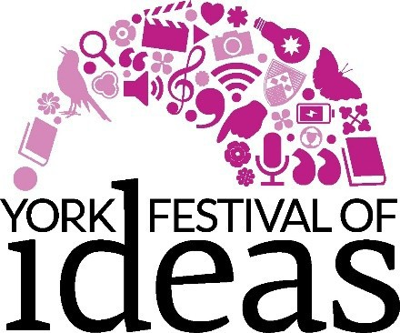

Hands on History, People and Pots, hosted by the York Festival of Ideas

Date: Friday 12 June, 10.30am to 12.30pm (tailored to adults with sight loss)
Venue: Patch, The Bonding Warehouse, Terry Avenue, York, YO1 6FA

Event details
Pottery is part of our everyday life and has been for the last 6,000 years. Join archaeologist Julian Richards as we get ‘hands on’ with the raw materials (prepare to get clayey!) and explore how pots have been made, decorated and fired through the ages. And as well as handling a wide range of pottery, you’ll also meet some of
the fascinating characters that are a part of this ‘potted history of Britain’.

About the speaker
Julian Richards is an archaeologist and broadcaster who has devised and taught many courses for the visually impaired. He specialises
in the prehistory of Britain and has a long-standing involvement with Stonehenge. He has directed major fieldwork projects and worked
in both commercial archaeology and for English Heritage before a career change to broadcasting and education. Julian presented programmes for the BBC, both on TV (Meet the Ancestors and Blood of the Vikings on BBC2) and on radio (Mapping the Town on Radio 4). Julian is passionate
about bringing the past to life and is involved in writing, devising and delivering community archaeology projects, working with schools, making non-broadcast film and curating museum exhibitions.
To book your free ticket, please email MySight York at hello@ mysightyork.org or phone 01904 636269.

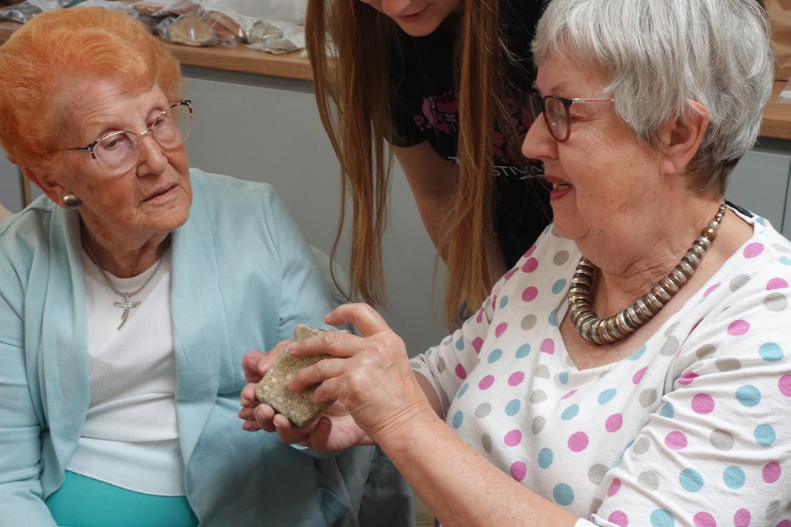
Previous attendees at one of Julian’s workshops
9

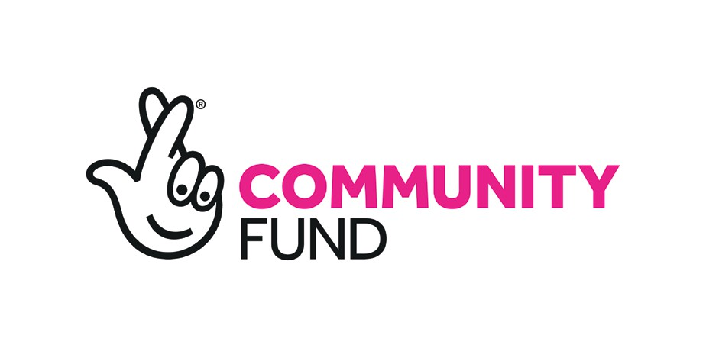
Digital Vision in Support of Health and Wellbeing

We are delighted to announce that MySight York has been awarded funding from The National Lottery Community Fund to deliver: Digital Vision, Bridging the Digital Divide After Sight Loss.
This funding represents an important step forward in ensuring that no one is left behind in an increasingly digital world.
As essential services, healthcare systems and social connection increasingly move online, the ability to navigate digital spaces has become central to everyday life.
Without specialist support, people with sight loss risk being excluded from opportunities that others take for granted. Digital Vision has been developed as a direct response to this growing inequality.
The project will offer personalised guidance, peer-informed learning opportunities and community-based activity that support digital independence. The project will also work with local organisations to strengthen digital accessibility more broadly, helping to embed inclusive
practice across the city.
We wish to begin this process by running a series of consultations to discover need and help inform the direction of the project.

Consultations to Take Place in Spring / Summer 2026
Digital Café Consultation Date: Thursday 2nd July 2026
Time: Drop In from 1pm - 2:30pm
Where: MySight York Premises
This is an opportunity for you to come and inform us about what aspects of the assistive digital world you would be keen to learn more about in a sociable group setting. (please let us know if you intend on joining us for this session).

Indoor Rowing Consultation Sessions
When: Every Friday 12:30 - 13:30
Where: The Boathouse, West Esplanade, York YO1 6FZ
Booking essential through MySight York
We would like to invite you to attend in-door rowing sessions at York City Rowing Club in order to answer occasional questions on the accessibility of your experience. In particular, we would like to evaluate the the ErgData app which enables

you to access information on how frequently you are taking strokes and how fast you are moving, using speech or large font / high contrasted text. If you require assistance to download the app and learn how to use before you attend the first session, then please contact Bex on 636269.

Robin Norton, Indoor Rowing Coach, York Rowing Club said:
“We believe that rowing is a sport that almost anyone can enjoy.
Rowing is a low-impact, whole-body workout. This may be the ideal experience for someone that would prefer dry-land or use as a progression step towards the water. We hope you can give indoor rowing a try.”

Learning to Listen to Tai Chi and Qi Gong Consultation
When: Wednesday afternoons to be
confirmed
Where: MySight York Premises or online
Through MySight York, UK Tai Chi offers seated Tai Chi and Qi Gong sessions on a regular basis. Due to demand and feedback from
attendees, the need for an online or audio-only ‘Learning to Listen to Tai Chi and Qi Gong instructional short course’ was shown to us as being
highly beneficial.
“I would benefit from more audio description of the moves.” Tai Chi Member
“As there is a waiting list for the group and a year full of bank holiday Mondays, I would really appreciate the option to practice both independently and accessibly.” Interested member
Please let us know if you have an interest in informing the creation of the course as an existing or
former MySight York Seated Tai Chi attendee.

Contact vicky.colombi@ mysightyork.org or call 01904 636269 to book on any of the special projects.

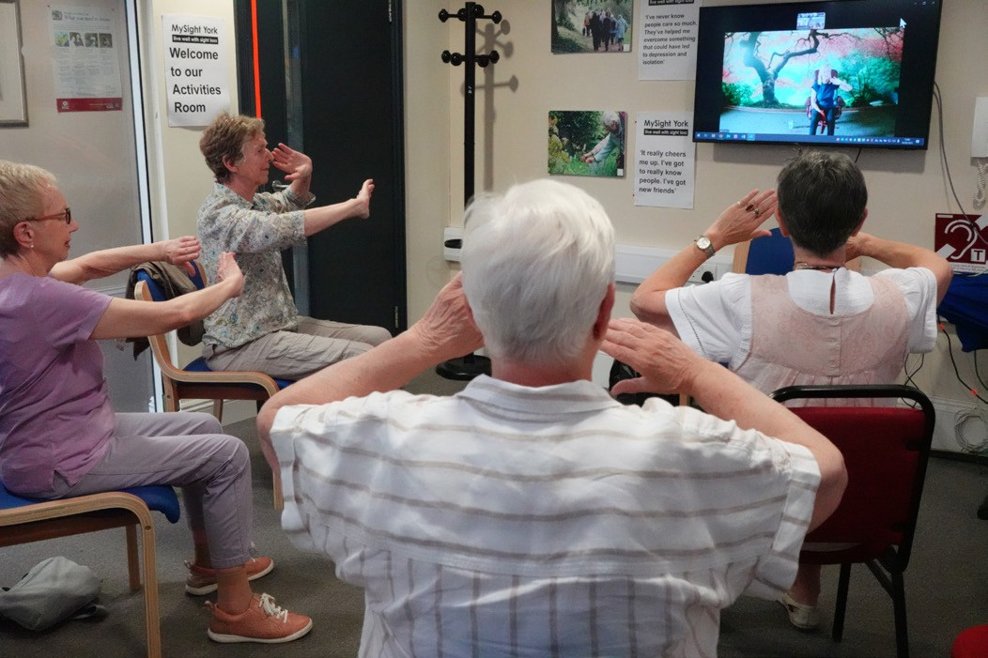
Attendss at Tai Chi

11

Built to Last: Securing Our Future Together
Our membership has increased substantially in recent years, and MySight York remains in good health. Our team is dedicated and our services strong. However,
no charity can take its future for granted, and the core services our members depend on are funded almost entirely through charitable giving.
As we enter our 47th year, we are being prouder and more forthright in asking for the support our members need to live well with sight loss. We hope you will join us in this mission and consider making a gift to secure MySight York’s future.
Open to all. Funded by you.
MySight York is an independent charity, and last year 89% of our services were kindly funded by donors, charitable foundations, and people who remembered us in their Wills. Our services are free of charge, but not free of cost,
and your support can ensure they remain available to all who need them.
There are currently 7,140 people in York living with sight loss, rising to 8,410 by 2032.To keep pace with
rising need our funding must grow alongside it.

Long Live MySight York — Jeremy’s Story
Jeremy lives with retinitis pigmentosa, experiencing no sight in one eye and minimal vision in the other.
“There are so few places that truly understand the realities of living with sight loss. That understanding matters enormously, and is exactly what sets MySight York apart.”
Without the right support, people with sight loss can quickly become isolated. MySight York helps to change that by offering practical support, understanding and reassurance at a time when people often need it most. Long live MySight York, and may you
continue the work that makes such
a great difference to our lives.”
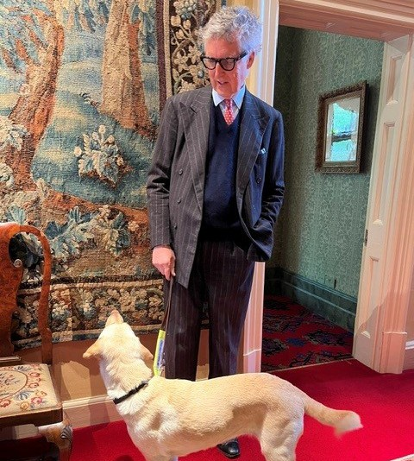
Jeremy, MySight York member

Investing in the Next Generation
When MySight York was founded in 1979, the world was very different for people with vision impairment.
We have come an enormous distance since, and envision a future where accessibility is
integrated seamlessly into public life: into healthcare, architecture, technology and education, amongst other aspects.
Remembering MySight York in your Will is a powerful way to realise
this vision. Gifts in Wills funded 36% of our services in 2025-26, and remembering MySight York is remarkably easy. Simply instruct your solicitor or Will-writing service to include our name and charity number:
MySight York, Registered charity number 1159188
Leaving even 1% of your estate to MySight York keeps 99% with your loved ones, yet can make a profound difference to future
generations of people with vision impairment in York. You can also include us in your Letter of Wishes, which is even simpler to complete, though does not carry the same legal standing as a Will.
Please Support Us Today. To give a sense of what your support makes possible:
- £25 funds expert support with
our Eye Care Liaison Officer
- £50 can rekindle a love of reading by funding a reading assessment
- £100 brings companionship by funding a trained befriender
All donations are gratefully received, and are increased by 25% if you are eligible for Gift Aid. Regular gifts allow you to build your support over time and help us plan for the future.
You can donate:
- Online, by visiting mysightyork. enthuse.com and clicking ‘Donate’.
- Via text, by sending MYSIGHT followed by the donation amount (e.g., MYSIGHT5) to 70490. Texts
cost the donation amount plus one standard rate message.
- By cheque, made out to ‘MySight York’ and posted to: MySight York, 84-86 Walmgate, York, YO1 9TL
For assistance making your gift, or to discuss any aspect of fundraising, please contact Will Evans at will. evans@mysightyork.org or on (01904) 731 127.
With Our Deepest Gratitude
To everyone who has donated, volunteered, fundraised, or remembered us in their Will, please accept our sincere and heartfelt thanks. We go into our 47th year proud of what we have built together and, with your continued support, the best is still to come.

13

Summer - Volunteering Focus
Hello everybody! It’s been lovely to see so many of you lately and have the opportunity to catch up with you. (I have heard that my tea making skills have improved since the last newsletter) I’m now officially three quarters of the way through my first year as Volunteer
Coordinator with MySight York and
my goodness, time has flown!
Personally speaking, it’s been such a rewarding journey, and I’ve loved getting to grips with the role along the way. Learning “on the hoof” has certainly kept me on my toes (and occasionally reaching for an extra cup of tea), but I feel so much more confident with each passing month.
A huge part of that is down to all of you members and volunteers - your support and encouragement means a lot. Do let me know if you have any feedback for me, your
ideas and constructive criticism are always welcome.
Until the next update - thank you all so much for everything you do. Your time, compassion and commitment make MySight York the supportive community it is!

Celebrating Volunteer Impact
This year we have welcomed in 7 wonderful new volunteers into the fold and started 5 successful new befriending relationships.
Activities volunteers continue to keep our groups going like
‘clockwork’ and ensuring that they are fun, friendly accessible for everybody. Befriending volunteers have donated over 300 hours
of their time to bring comfort, companionship and connection to members who would otherwise feel lonely. Our fundraising volunteers have been fantastic in welcoming Will, and their enthusiastic
support at events and stalls has helped kick-start our community fundraising again.
I’ve been really impressed by the care, diligence and pride MySight York volunteers show every day. Thank you for all the incredible work and care you put into your volunteering with us.

We need Volunteers – Help us get the word out
We have some volunteer gaps to fill including Trustees, Fundraisers, Befrienders, Outreach and Finance volunteer roles - can you help us fill them? If you or someone you know is interested in learning more then please do get in touch with us for a
chat. We have put together a poster to advertise our volunteer gaps.
Perhaps you could consider putting some of these up in your local area? Please find the poster enclosed in the newsletter.

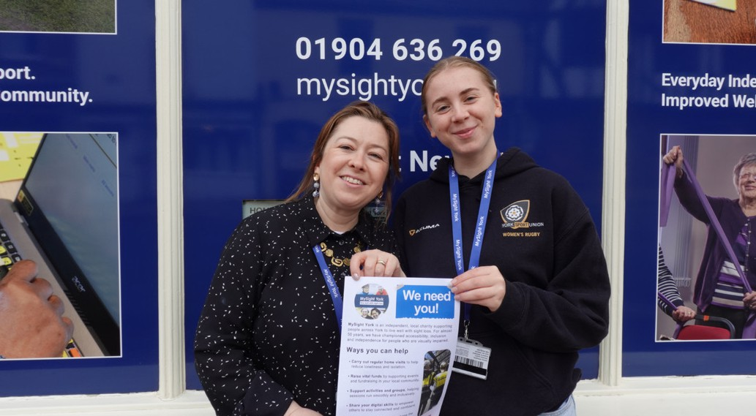

Volunteer Spotlight – Meet Megan
Hi everyone! I’m Megan, and I am the new Befriending Client Monitor here at My Sight York. I have been at MySight York since February and have felt welcome ever since. In my role, I bridge a gap between our befriending service and the people who use them.
I spend my time speaking with clients on the phone about their befriending experience. When I am not speaking to clients, I create resources for new Befrienders, meet clients and keep our referral resources up to date.
Hearing everyone’s stories and experiences is really nice to listen to and ensures that we are not only providing the right support but also identifying areas where we can grow and improve to better
serve our community. It is incredibly rewarding to see what goes into the work here. I really enjoy talking to clients about their day and seeing how their befrienders and MySight York have helped them. It is the highlight of my week!
Outside of volunteering, I am a Law Student at University. My time at My Sight York has helped me massively; it has boosted my confidence in public speaking and has helped me develop the communication skills I will need in my future legal career.
I am so proud to be part of such a supportive environment, and I look forward to speaking with many more of you very soon!

Time together is time well spent.
Well, I have to say the monthly mingles are going down well!
It’s lovely to see a nice bunch of volunteers every month and having an opportunity to ‘down tools’ and get to know each other with a cup in hand. These are very informal affairs, and all volunteers are welcome to join a ‘mingle’. Mingles take place on the last Friday of every month. Just get in touch with Tanya if you would like to attend.

Volunteer Check Ins and Support
If it has been a year or so since your last supervision meeting, then do get in touch and I’ll set some time aside for us to get together
to assess how your volunteering journey is progressing. It may be that we need to make any changes or adjustments. Consider this your yearly MOT with tea and biscuits included.

15

Volunteering Spotlight

Being able to find and identify items and information around your home can sometimes be frustrating and tiresome. Creating organised spaces where everything has a dedicated position can help. Using no tech and low tech solutions
or exploring new tech to identify objects, functions and information can be worthwhile exploring.
Be organised. “A place for everything and everything in its place” is the well-known mantra used by Connie to help find and return to items each time she wants them. Creating clear spaces where your important things live can
ease the pressure of searching. Using boxes, bowls & shelves to place items in your known place for you to return to again and again can really help. Just don’t let well-meaning friends and family reorganise or move your stuff to unfamiliar spaces!
Using contrasting colours help an object standout from its background because of its colour or tone. Contrasting door frames to the door and walls can make doorways easier to pass through. Using day glo tape around a light switch or on significant buttons Using a bold black ink pen and
sticky white labels can help re label items in a more readable size.
Managing the right level of lighting and managing glare is worth
exploring too.
Elastic bands. Placing elastic band arounds bottles and jars can make them more identifiable by touch. Useful for when you want to quickly grab and use such as your shampoo in the shower or distinguish between peas and peaches in your cupboard.
Bump -ons - renamed recently as BumperStops - are a very popular way of marking settings and functions on many household and office products. At 3mm high the self-adhesive markers help you identify by feel of the tactile bump or by its colour. Loc dots come in packs of six and are only 2mm in height and work very
well on laptops and keyboards. There is no right or wrong when labelling products, if it helps you to understand, find and use a function then its labelled correctly!

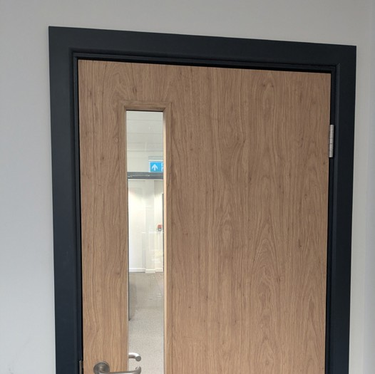
BumperStops 72 per sheet- £7.00 or 10p each
Loc dots £3.50
Day-glo orange tape 2.5cm wide 25m long £10.80

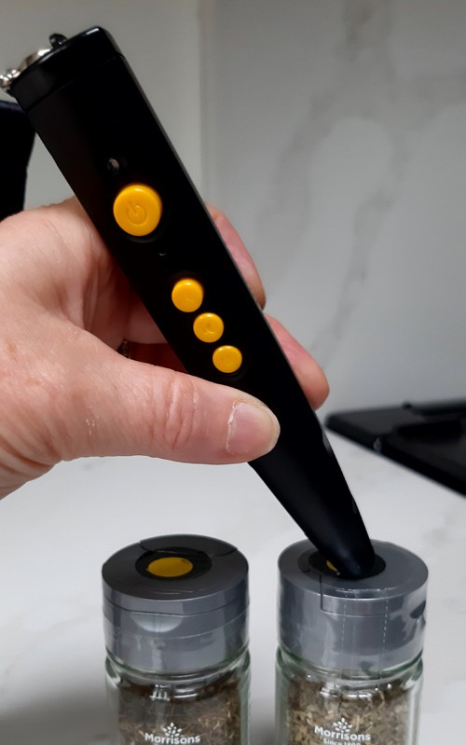
Penfriend 3 audio labeller - an easy-to-use labelling device lets you record your own voice onto labels to be used in lots of different ways, from the kitchen, music collections clothing,
medicines paperwork, garden plants, freezer items, laundry and beyond! Almost anything can be identified. Simply touch the Penfriend to a label to hear back your own recording. With up to one hour recording time per label you can create comprehensive
information without feeling rushed.
If you make a mistake or want to reuse the label again you can re-record a new message. RNIB
£95.00


New Speechlabel app and Habel labels
Use your smart phone to download the free Speechlabel App from your Phone’s app store
and buy the easy scan Habel labels to give you an alternative way to help you identify everyday items.
The stickers are an advanced version of a QR code called an Aztec code. This means that they only need to capture about 10% of the code for a quick, accurate scan and you don’t have to worry about
aligning the sticker with the camera
Download the free Speechlabel app onto your phone, (suitable for both iOS and Android) scan the sticker with your smartphone camera, record voice message or type a short description. The next time you scan the same sticker the app will instantly play back or display your saved information
Habel Starter pack – Assorted labels £16.00
Each pack contains 25 thin QR code stickers for disposable items such as groceries, thick QR codes resistant to wear and fading, moisture resistant and designed for storing long term information, 5x Touch NFC stickers, strong and
long lasting great for labelling things you use long term, 5x NFC laundry buttons 20mm in diameter soft, flexible and washable.
All labels are available in bulk packs. You can also choose to save your audio labels in the cloud and share them with other people.
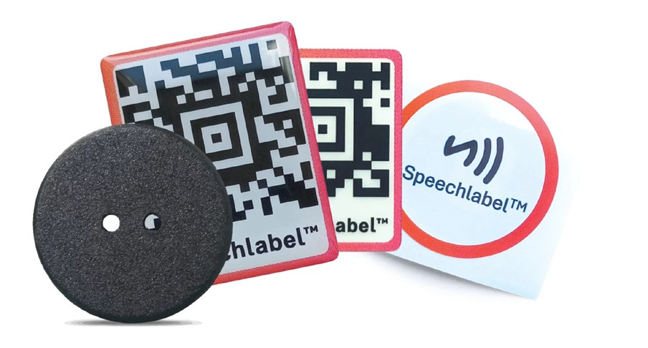
Please ring on 636269 to book an appointment in person or to talk over the phone about the equipment and ideas mentioned.
17

It’s not the winning it’s the taking part.
This year, North Yorkshire‘s visually impaired (VI) Tennis players managed to do both. In a league organised under the Lawn Tennis Association (LTA), teams from York, Sheffield, Leeds and Hull, competed across a range of sight categories from players with no vision to those allowed additional bounces. After months of matches played across the region, North Yorkshire emerged as winners.
The success was celebrated at the Yorkshire LTA presentation dinner on the 19th of March, where several players attended to receive certificates and a well earned trophy. At the heart of this achievement is the weekly VI Tennis session in York, run by Mysight York.
Every Monday at the University of York, players take to a slightly smaller court using a foam ball with a bell inside. Depending on visual ability, players can have up to 3 bounces, making the game
accessible, competitive, and above all enjoyable. For many people these sessions are the highlight of the week. They offer more than just exercise, they provide friendship, laughter, and a strong sense of community. New players often arrive feeling unsure, “Will I hit
the ball?” ‘Will I even see it?” With coaching from Rob Hodge and encouragement from fellow players
confidence quickly grows. What begins as uncertainty soon turns into enjoyment, and for some even competitive success.
The atmosphere on court is lively and full of humour. Friendly
disputes over line calls, miscounted bounces and the occasional dramatic protest often suggesting the umpire needs a visit to the Opticians, are all part of the fun.
Coach Rob, who supplies all the equipment, has seen the program grow steadily over the past
three years and values the mix of personalities that make each session unique.
The 2 regular volunteers, Mark and Chris, also play a vital role helping
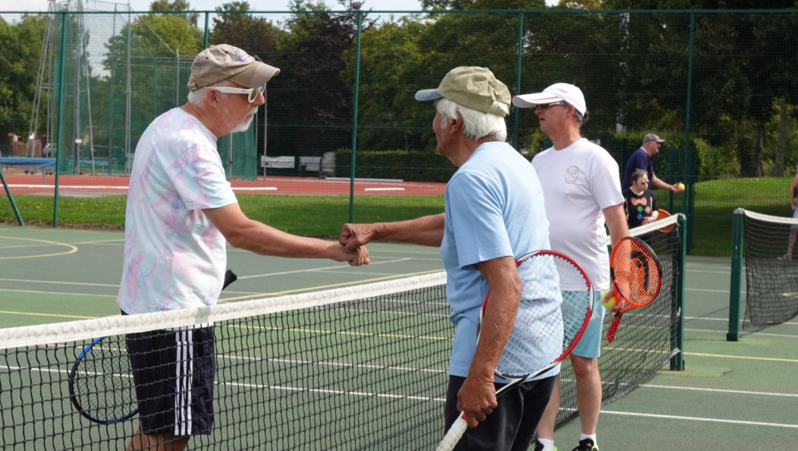
sessions run smoothly while joining in the spirit of the game. VI Tennis in York isn’t just about sport it’s about connection ,confidence, and community. Thank you to Mysight. Contributors: Graham, Jayanti, Rachel, Dave, Rob, Chris. Team members Anne, Lindsay. Compiled by Paul



Instructions for listening to MySight York newsletter on Alexa device.
Did you know you can access our newsletter using Alexa. Last month we had over 500 listners using the Alexa Skill.

To open the skill, just say: “Alexa, open MySight York”.
When you open our skill for the first time, we will provide you with handy hints and tips on how to use it.

You can listen to this help again by saying “Help” after opening the skill.

YORVIEW NEWSLETTER You
can listen to the latest edition of our popular YorView newsletter.
For example, you can say: “Play newsletter” after opening the skill. Alternatively, you can listen to previous editions of our newsletter. For example, just say: “Play previous newsletter” or “Play Spring 2023 newsletter”. You can pause
a newsletter and your position will
be remembered for one day. Our newsletters are split into tracks.
To move between tracks, you can say: “Previous” or “Next”. ---

Alexa
ACTIVITIES You can find out about upcoming activities at MySight York. For example, you can say: “What activities are available?” after opening the skill.
You can pause the activity newsletter and your position will be remembered for one day.

--- HELP If you need help at any time, you can say: “Help” after opening the skill. ---
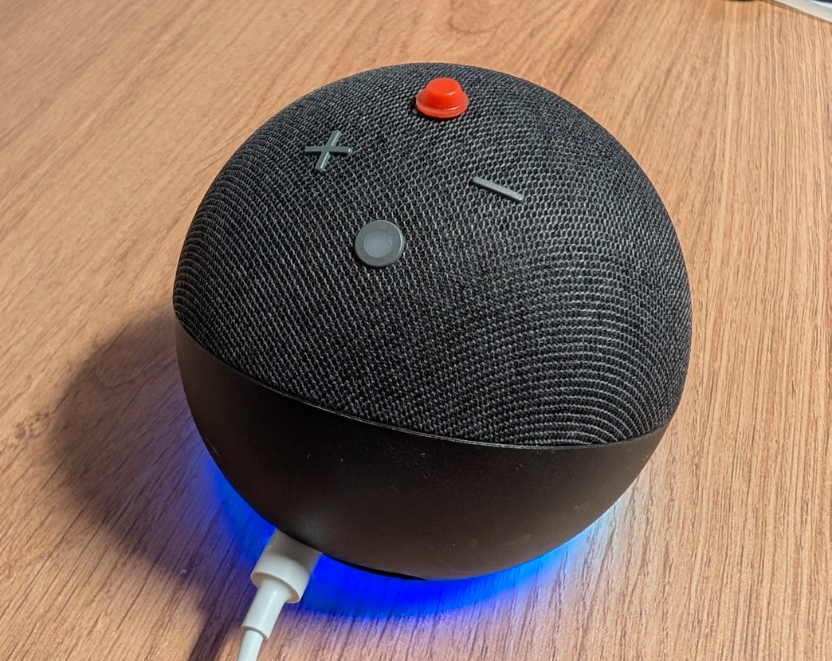

If you need any further support to access our newsletter using Alexa call us on 01904 636 269.

19

YorView is the newsletter of MySight York.

We know from the feedback we receive that many people value the newsletter as the most important way of receiving information about MySight York and issues that affect blind and partially sighted people and their families and supporters.

But, did you know all the different ways you can access this newsletter?
We produce:

1,251 in Large Print
39 on audio USB
40 on audio CD 3 in Braille
537 by email

Plus, over 500 people have accessed the newsletter on Alexa. For more information on how to do this please see page 19.

If you are receiving this newsletter in a format that isn’t right for you anymore then please get in touch so we can discuss what would work better.

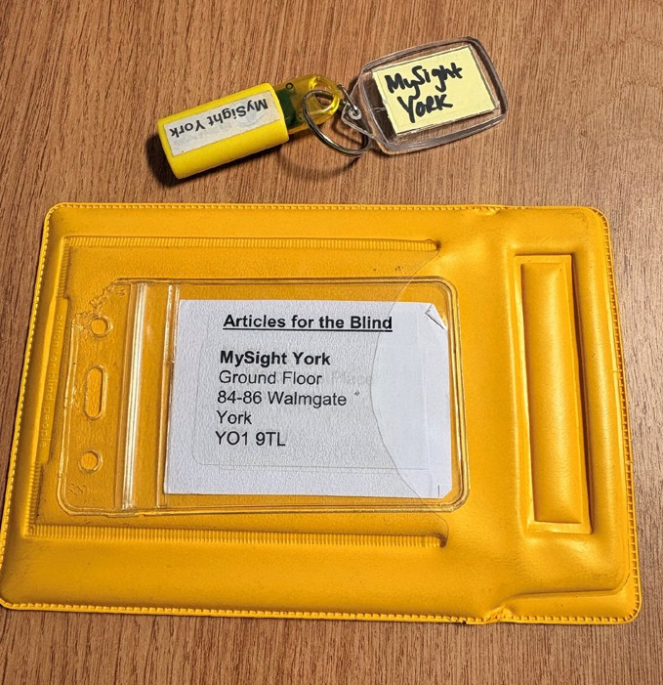
There is a significant cost involved in producing the
newsletter, for example, each USB costs around
£10 including the wallet used to post it. If you are receiving the newsletter on USB please ensure it is returned in the yellow wallet. All you need to do is turn over the address label and pop it into any post box – no payment is needed.

Should you, or a family member, no longer require the newsletter then please also let us know so we can update our mailing list. If, however, you know of anyone who would benefit from receiving information from us then please do encourage them to give us a call on 01904 636269.

