Windows Typing
This is a tool to enable you to use your voice to type rather than using a keyboard.

To enable Voice Typing:
Press  + H → this will bring up a box on your screen
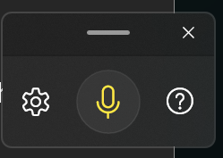
In order to voice type click in a textbox → Click on the microphone, it will highlight to indicate it is listening.

