Windows Magnifier
A free accessibility feature that allows you to fully zoom into the screen and move around.

How to enable
Go to the Windows key → Settings → Accessibility → Magnifier → Magnifier toggle the Off to On. Once activated a box will appear:
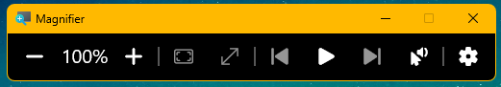

The following are quick access keys:
Keys | Action
 + ESC | To turn off
 + Plus key (+) | Turn on

How to use
Magnification
The following are hotkeys to control magnifier functions:
Key | Action
 = Plus key (+) | Zoom in
 + minus key (-) | Zoom out
Ctrl + Alt + mouse wheel | Zoom in or out

There are different views you can use whilst zoomed, they are as follows:
Zoom Type | Keys to change to | View style
Full Screen | Ctrl + Alt + F | This will zoom into the full scree. To navigate the screen, scroll your mouse pointer to the edge of the screen and it will move around the zoomed full screen.
Docked | Ctrl + Alt+ D | This will place a strip along the top of the screen. Withing this strip, the information your mouse is pointed at will be magnified.
Lens | Ctrl+ Alt + L | This is like holding a magnifying lens on the screen. The information in a small area around your pointer will be magnified to the selected level.
Switch between views | Ctrl + Alt + M | This will switch between the 3 view modes for quicker comparison

Within the Accessibility menu in settings, you can click on the View button to bring up more options for the magnifier modes. These are different for each mode:
Full Screen
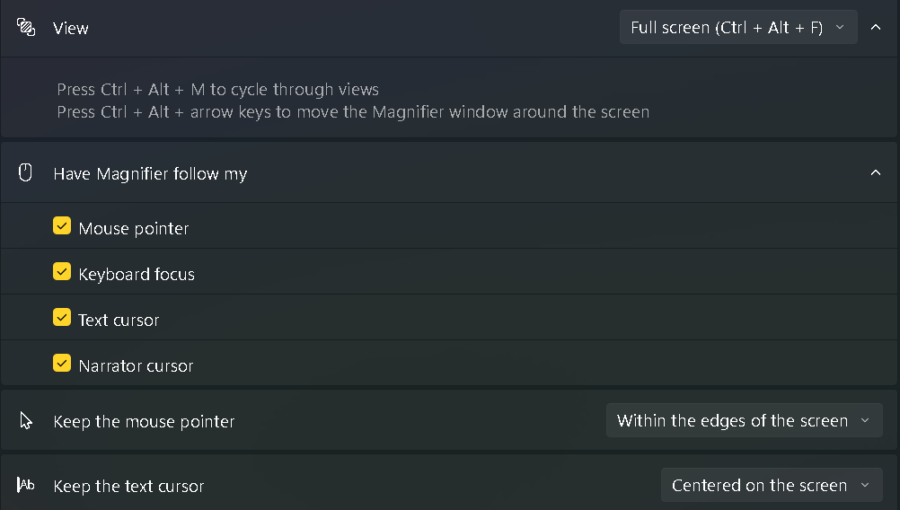

Lens
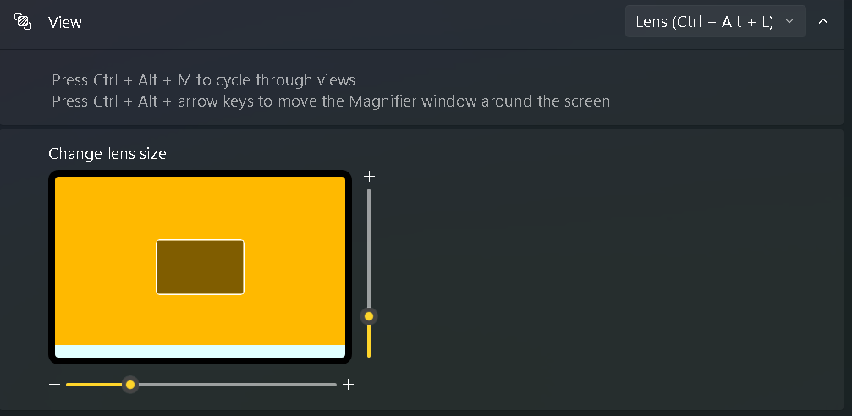

Docked
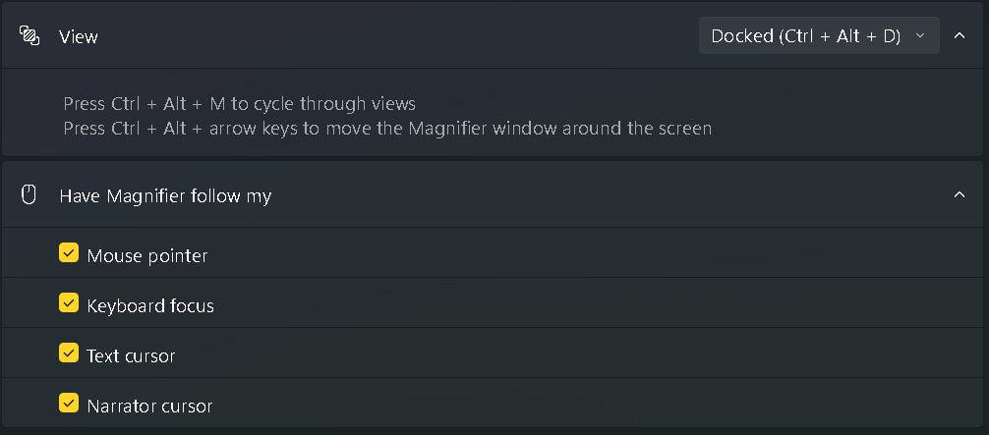
These can be adjusted to suit your preference.

Appearance
There are also options to invert the colours on the screen. This can be switched on and off by pressing :
Ctrl + Alt + I
Within the settings for the appearance, you can turn on smoothing of the edges of imaging and text. This will make both text and images look clearer when magnified.

Reading
The toolbar which popped up once the magnifier was enabled has a section for reading aloud to you.
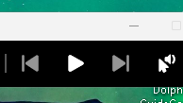
If you press the play button whilst in a word document, it will read aloud from where your cursor is. You can skip forward a sentence and back using the right and left arrow keys.

If you are on a menu you can use the click to play.
The following are the reading hotkeys:
Keys | Action
Ctrl + Alt | Reading shortcut ( can be changed to:  Caps lock  Insert  Caps lock or Insert  Go into Settings → Accessibility → Magnifier →Reading)
Reading Shortcut + Enter | Start/ pause/ resume reading
Any key | Stop reading
Reading shortcut + Left mouse click | Read from mouse point
Reading shortcut + H | Read previous sentence
Reading Shortcut + K | Read next sentence

You can also change settings from the toolbar like voice, and reading speed.
