How to get RNIB talking books on an Apple or Android

What is it?
RNIB talking books is a free service which has over 34,000 audio books which you can access in a few different formats. This can be by free-post USB stick and CD, Amazon Alexa speaker, PC, Mobile or tablet. In this case we will look at how to access the talking books on your Apple or Android device.

How to set it up, step by step
You will need to register with the RNIB reading services. This is free to visually impaired and blind users to register and create an account. This will allow you to have free access to their complete library.
Complete the following steps to register and be able to listen from your device:

- Open your chosen web browser on your device. This may be safari on the Apple devices, or chrome, google, firefox on other devices, and go to:
Home - Reading Services ( press CTRL and click on the link)

There will be a menu bar along the top of the page in grey. On the left of this bar, you will see the words “register” and “login”. Press “Register”.
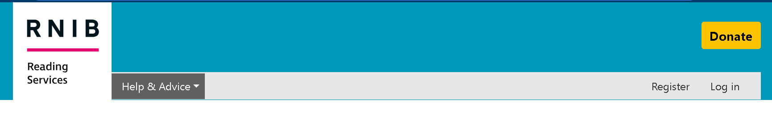

If you cannot see this on the bar, click on the box containing the 3 horizontal lines at the top left, just below the RNIB reading services logo. 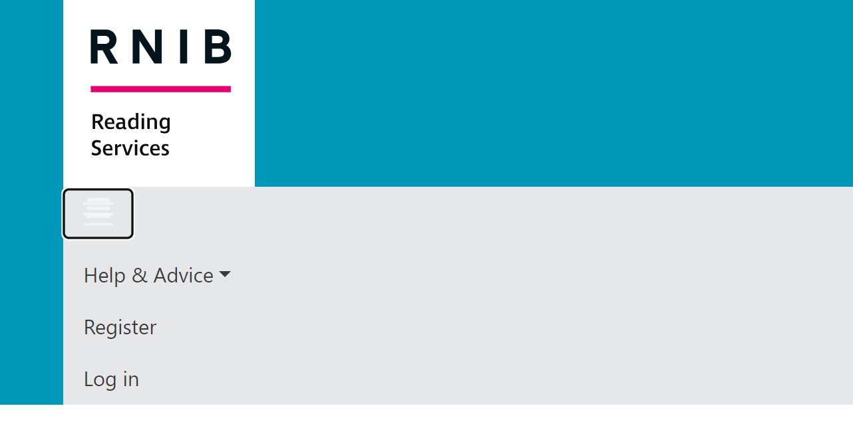
This will open a drop-down menu with the option’s “register” and “login”. Click “Register” to create an account.

- Follow the steps to create an account. Make a note of your email and the password you create as you will need this later.

This registration process will ask you for your email address, personal details, date of birth and address to create an RNIB reading services account. You will also be asked to create a password so you can enter the account.

- Once registered you will need to download a free app onto your device called Dolphin Easy Reader. This app will allow you to access the RNIB talking books library.
To do this go to your Apple App store on your Apple device or Google play store on Android devices
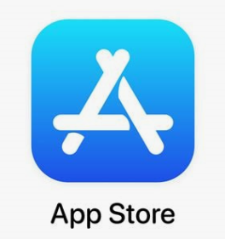 Apple 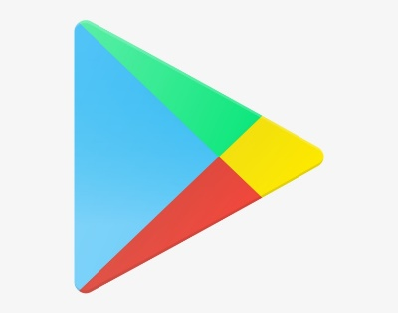 Android

- Type in Dolphin Easy Reader onto the search bar. To find this look at the top of the window where you will see the word search and a bar beneath. Click in this bar to type “Dolphin easy reader” and press the enter button on your keyboard. The app will look like this:
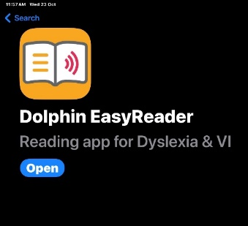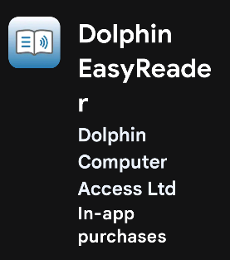

- Click “Get” or “Install” this will download the app.
*NOTE: You may be asked to input your Apple ID password or press a button on you’re an Apple device. If asked complete this to progress to the next step.
On Google you may be asked for payment information, you can press “Skip” as this is a Free app, no payment information is needed. *

- Once downloaded open the app. In the app you will see a contents list of different reading access points. You need to click on the RNIB Reading Services.
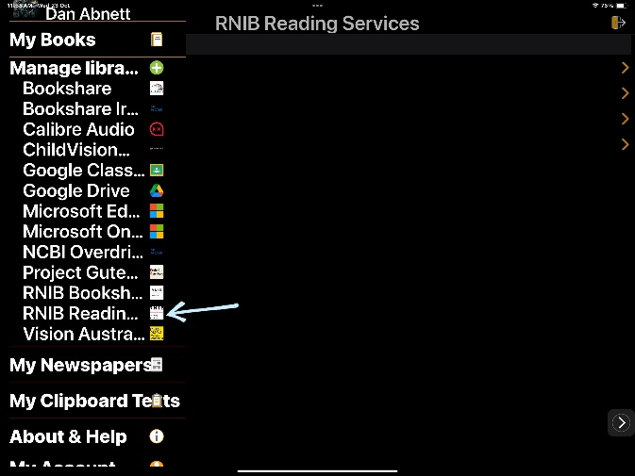

- This will then pop and ask you to allow it to go to the RNIB reading services login page.
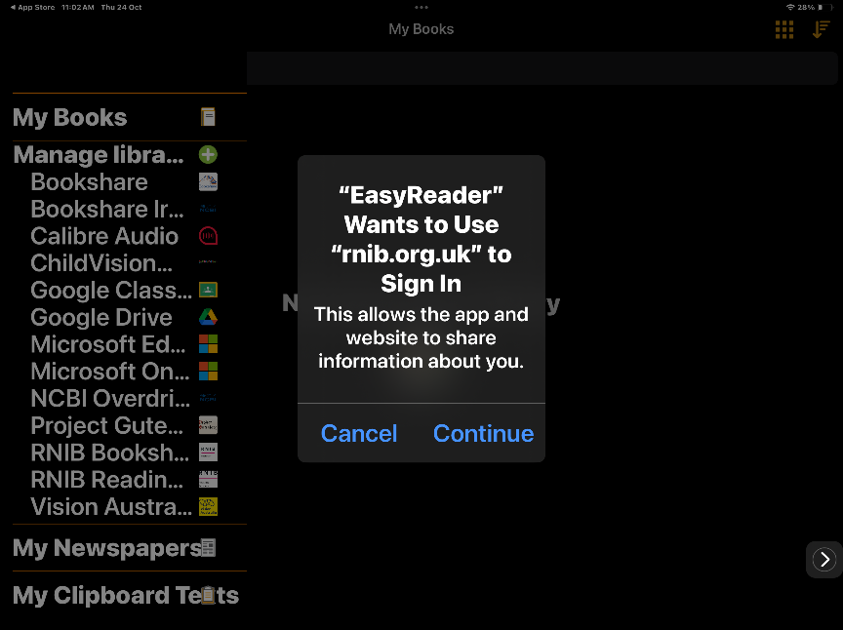
Please click the button to “continue” this.

- You will now be taken to the RNIB reading services login page.
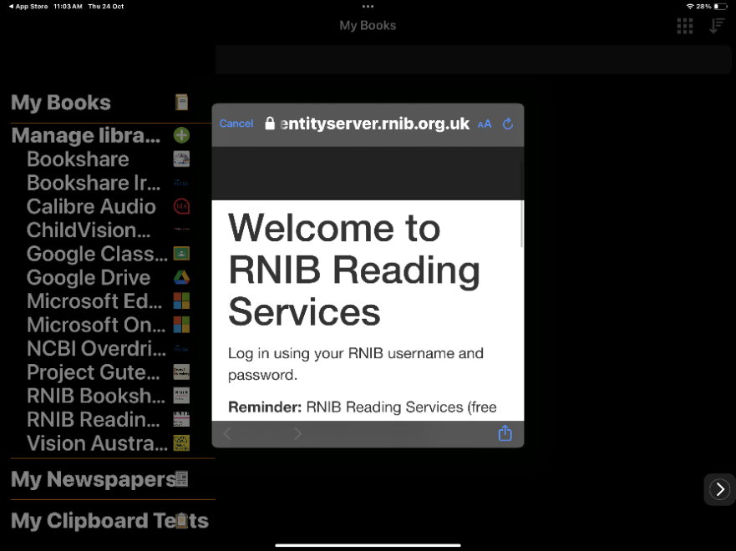
If you scroll down in this window, you will see a login page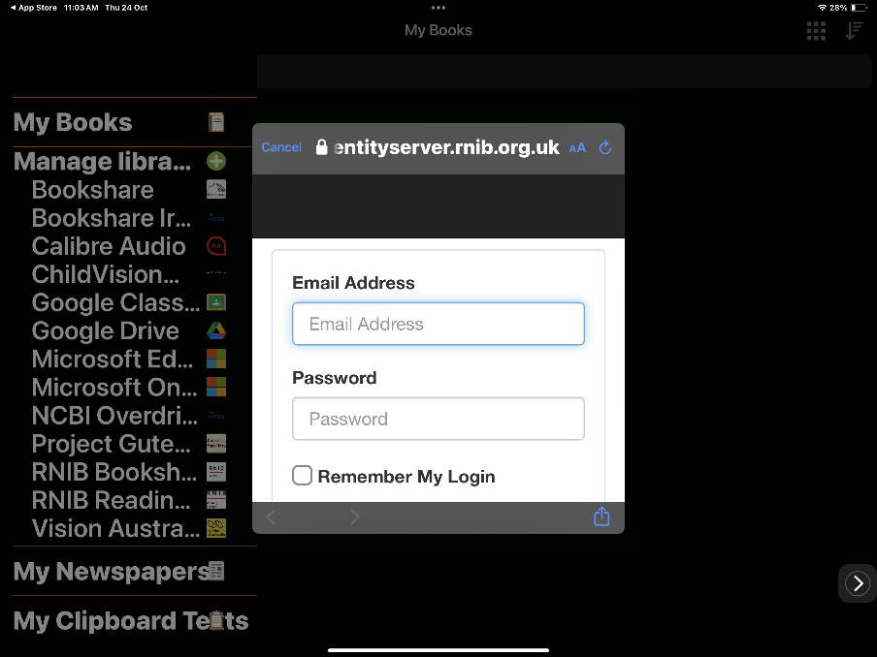
Please enter your email and password for the RNIB reading services. If you select the “Remember my login” you should not have to do this step again.
(NOTE: If you do not already have an account you may need to go to the website to register. See step 1.) 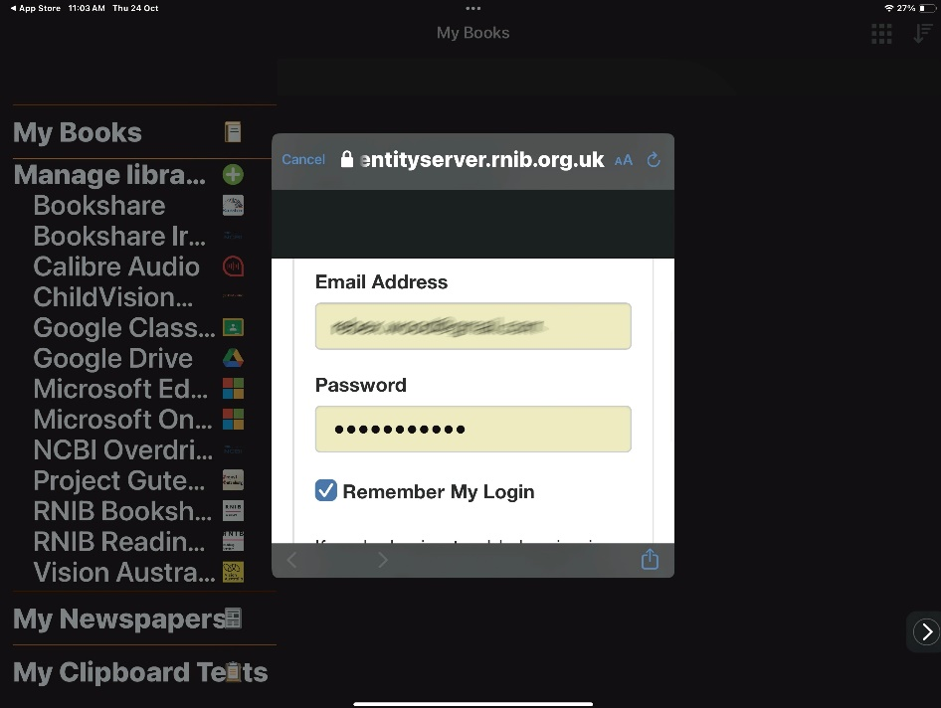
Click “continue” to complete the login step. You can now use your Dolphin Easy Reader app to access RNIB talking books.

How to use
Once you have logged in and ready to use the app you will be presented with a search bar at the top of the page and menu of 4 options:
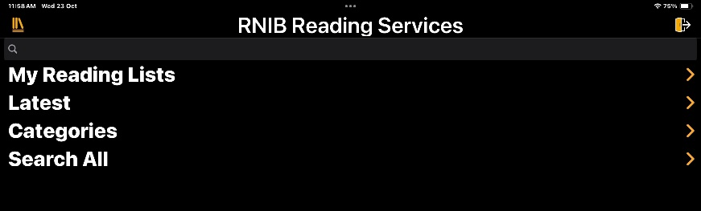
- My Reading Lists – this will bring up a list of your books

- Latest- this will bring up a list of recently added audiobooks

- Categories – this will bring up a list of all the categories to search these for books relating to these

- Search all – this will search all the books available
Once you have found the book you would like to listen to click on download. You will then be able to listen to these at your leisure.

