Microsoft Edge – Immersive Reader
Immersive reader is an assistive program within Microsoft Edge web browser, that is used when viewing websites. The immersive reader changes the view of the page into an easier to read format. It has a number of settings that can be change to make your reading experience more comfortable and accessible. Some sites may not work with the reader for the full site, but you can select any text on a page and view in the immersive reader.

How to enable the immersive reader
Open Microsoft Edge web browser and go to the website you want to view. Not all websites are available for full use with immersive reader. However, you can still read selections of text in the immersive reader.

- If the site is able to be used fully with the immersive reader there wull be an option to selec it on the address ber. Along the address bar at the right end there will be a circle with 3 dots inside, click here to find the immersive reader menu
 Click on this icon to enter the menu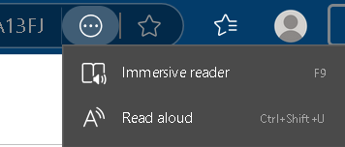
Then select the Immersive reader
- Another way to access the reader is by typing read: into the address bar in front of the https:// address like follows:

This will put the page into the immersive reader mode. **Not all websites will work well with this.**
- If the website you are viewing does not work well with the reader for the full page, you can select a body of text on the page. To do this
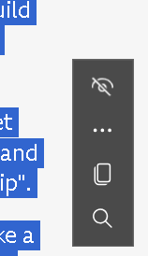
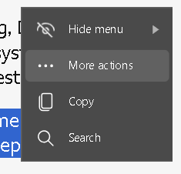click on the 3 dots for more actions. This will open a menu for the “open section in immersive reader”
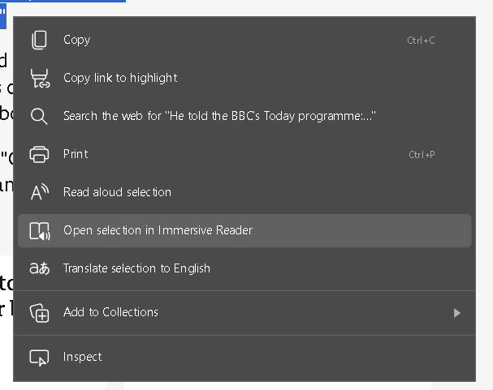
This will open the selected text in the reader and allow you to change the options.

Immersive reader
Once in the immersive reader you will be able to change settings to make your reading experience more accessible. These options are located below the address bar to the right
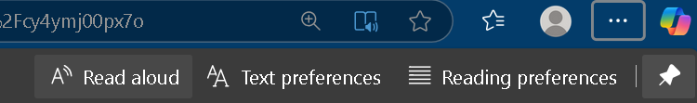
There are 3 available options to select.
- Read Aloud – This will take a couple of seconds, then begin to read the page out loud. You can play/ pause, forward and rewind.
- Text preferences – This will enable you to get the text preferences correct for you. Within this you will be able to change settings such as: text size, spacing, font, Text columns and style.
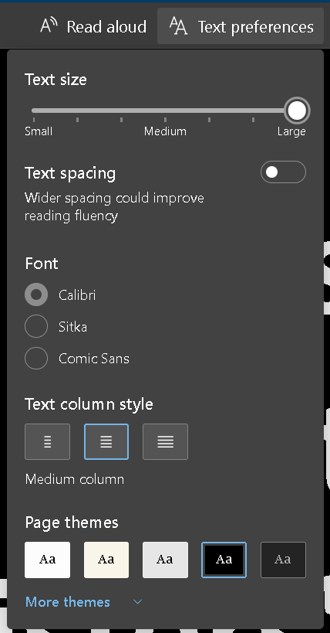
You can easily adjust the slider to change the size of the text on the page.

The text spacing will increase the space between each letter.

There are 3 font choices depending on what works better for you.

Text column style will change the margins of the text.

Page themes will allow you to change the colour of the page and the text within the page. More themes:

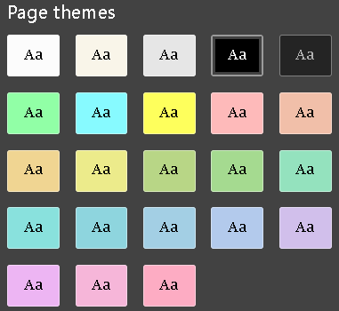

- Reading preferences – In this menu you can select a couple of options to help you read the text.
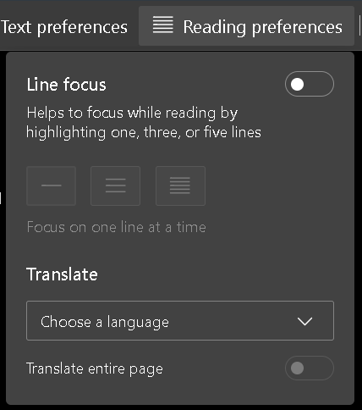
Line focus allows you to select the option which suits you best. You have the option of focus on a single line, 3 lines or 5 lines to help you follow what you are reading.

Translate, will translate the text into your chosen language.

The following are examples of the line focus:
Example of single line focus
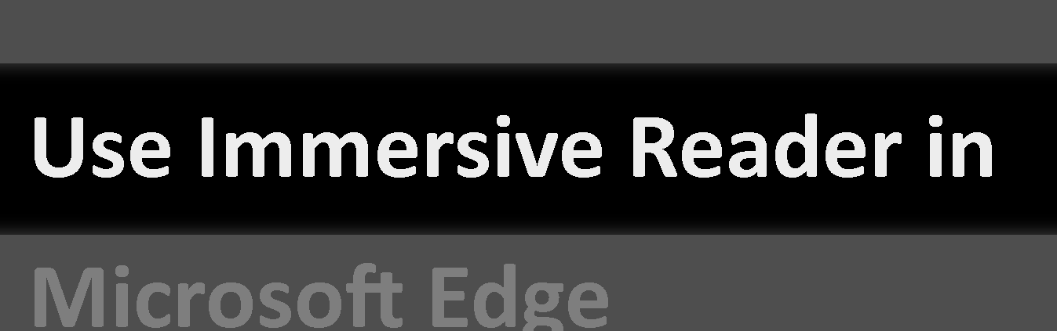
Example of 3 line focus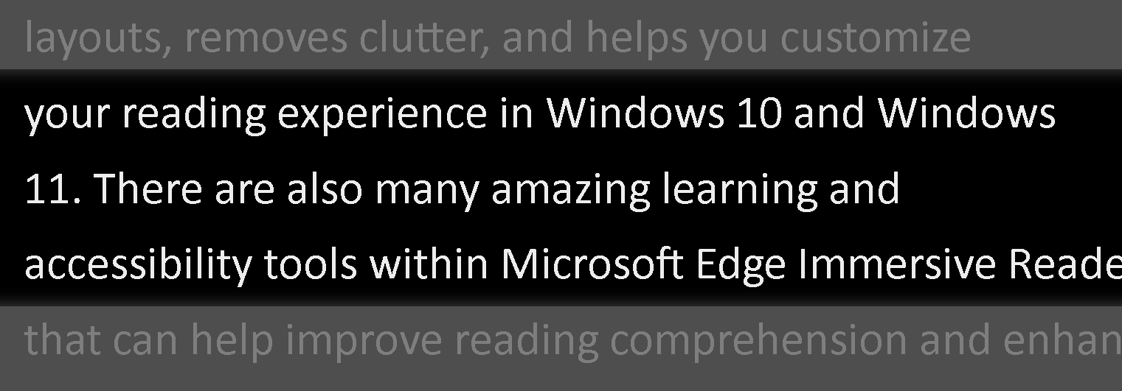
Example of 5 line focus.
