Amazon Alexa for RNIB Audiobooks

The RNIB audio library is available to be accessed using an Amazon Alexa device. The set up is required in 2 steps, the first is to set up an account with the RNIB Reading Services to access the audiobook library. The second is to enable the Alexa RNIB talking books skill.

RNIB Reading services ser up
If you already have an RNIB reading services account and know your login and password, please skip to Alexa skill set up.
- Go to Home - Reading Services (press Ctrl and click on the link to take you to the page or type RNIB Reading Services into google.

- In the upper right of the webpage there is a bar with register button, click register.
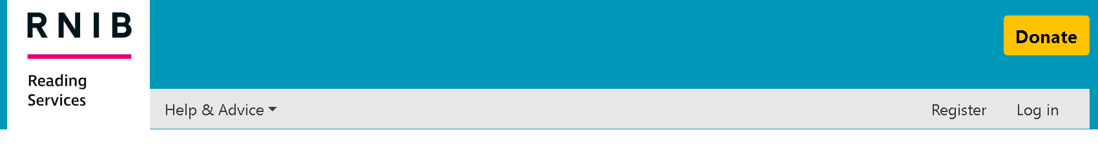

- From here, follow the on-screen instructions and provide the details required.

*Note -This registration process will ask you for your email address, personal details, date of birth and address to create an RNIB reading services account. You will also be asked to create a password so you can enter the account. *

- Once you have set up your RNIB Reading Services account make sure you make a note of your log in details. You will need these to link your Alexa skill.

Alexa Skill set up
To use certain things on your Alexa device you need to enable skills.
- Open your Alexa app on your phone or tablet. This will be on the device you originally set up the Alexa using.

- Along the bottom of the screen, you will see a series of buttons. Dependant on your phone settings you may see a button which says, “Skills & Games”.

If you do not see this option, find the button which looks like 3 horizontal lines. Press this button, you will be taken to a page with a series of boxes with more options. Find the box which says, “Skills & Games” and press it.

- At the top of this page there will be a search bar. Press in the search bar and type in “RNIB talking books” and press search. The top result should be RNIB Talking books. Press this option.

- This page will tell you what the skill is and have a button which says “Enable” press this button. This will take you to a page where you will need to login to your RNIB Reading Services account.

- Once this is completed you will see the words “Account Linking Linked” the linked will be in green.

- Now your account is linked, and skill is enabled you can begin using your voice to access RNIB talking books on Alexa.

Alexa Commands to access RNIB talking books

There are specific commands which you will need to use to access your audiobooks using Alexa.

To open the skill, say:
“Alexa, open RNIB talking books”
Once open Alexa will play a short tutorial and explain how the skill works.

You can ask to find books by authors by saying:
“Alexa, list books by [authors name]”

You can find books by title by saying:
“Alexa, find [say book title or keywords from title]”

You can find books by keywords by saying:
“Alexa, find books about [keyword/ theme etc]”

You can genre search by asking:
“Alexa, list genres”
Or
“Alexa, List [genre type e.g. sci-fi]”

You can access your bookshelf by saying:
“Alexa, list my books”
To begin playing a book from your list say:
“Alexa, [number of the book in the list]”
Within your bookshelf you can clear the whole list by saying
“Alexa, clear list”
Or you can individually delete books.

If Alexa begins to read out a list and you hear an option you want, say:
“Alexa [number of selection e.g. three]”

The commands whilst books are playing are as follows, all commands begin with Alexa then:
Play
Pause
Skip
Previous
Resume
Cancel
Volume up
Volume down

If at any point you get stuck or are unsure of what to do you can say:
“Alexa, Help”
For assistance on how to use the skill. If you have any difficulty with this skill, you can also contact the RNIB helpline on 0303 123 9999.

