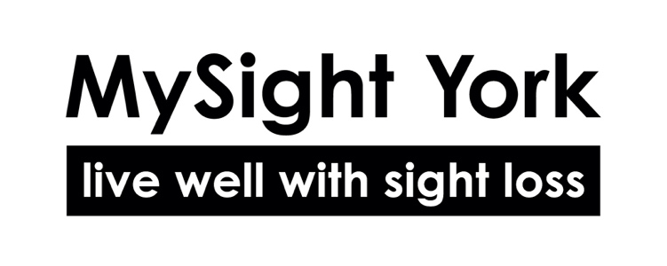
Volunteer Application Form

Name:

Address:

Landline:
Mobile:
Email address:
(Providing an email address reduces our costs and enables us to process your application quicker)

Date of birth:

Emergency Contact Details:
Name:
Phone Number/s:
Relationship:

Please write below the times you could be available to volunteer.

How did you hear about volunteering with MySight York?

Which role(s) are you interested in?

What is your interest in volunteering with MySight York in this role, and what do you hope to gain from this voluntary role?

Please provide details of the last 2 years work experience, both paid and unpaid.

Please outline any relevant previous or current work experience, including any volunteering.

Have you ever been convicted of a criminal offence?
(Declaration subject to the Rehabilitation of Offenders Act 1974)

Yes / No

If your answer is yes, please give details of date(s) of offence(s) and sentence(s) passed, which are not spent.

Are you currently named on one or more of the following lists?

- DBS Adults Barred List
- DBS Children’s Barred List
- Disqualified from working with Adults List (Scotland)
- Disqualified from working with Children List (Scotland)

or subject to sanctions imposed by a regulatory body such as the General Teaching Council?

Yes / No

Please tell us if you feel there is any additional support you may need to help you volunteer or any health conditions that we need to be aware of.

Please provide any other information here that has not been covered in this form and that you would like to add, or feel that we should know about.

GDPR Statement
Whilst volunteering for MySight York your details will be held on our secure database – Are you happy for MySight York to keep this information. Your information will be removed from our database after 12 months of you finishing volunteering with MySight York.

Yes / No

Preferred method of communication (correspondence and newsletters)

Standard Print
Email
Audio
Braille
Large Print (if so please indicate font size)

Photo Permission. MySight York occasionally use photos or video for publicity purposes. This may include our website, social media, printed publicity, press releases and publicity on external websites. Are you happy for MySight York to use photographs or video of yourself for this purpose?

Yes / No

Referees
Please give the names and addresses of 2 people who know you well enough to comment on your suitability for this role and who are not related to you. Please check with them that they are willing to provide a personal reference before you submit their names to us.

First Reference
Name:
Address
Telephone
Email:
In what capacity are they known to you?

Second Reference
Name:
Address
Telephone
Email:
In what capacity are they known to you?

I confirm that the information included in this form is, to the best of my knowledge, correct. If filling out this form electronically, please indicate your agreement by typing your name.

Signature:

Date:

Please return this completed form via email to: Catherine.bamford@mysightyork.org

or post to Catherine Bamford, Befriending Service Manager,
MySight York, 14 Merchants Place, Merchantgate, York, YO1 9TU

